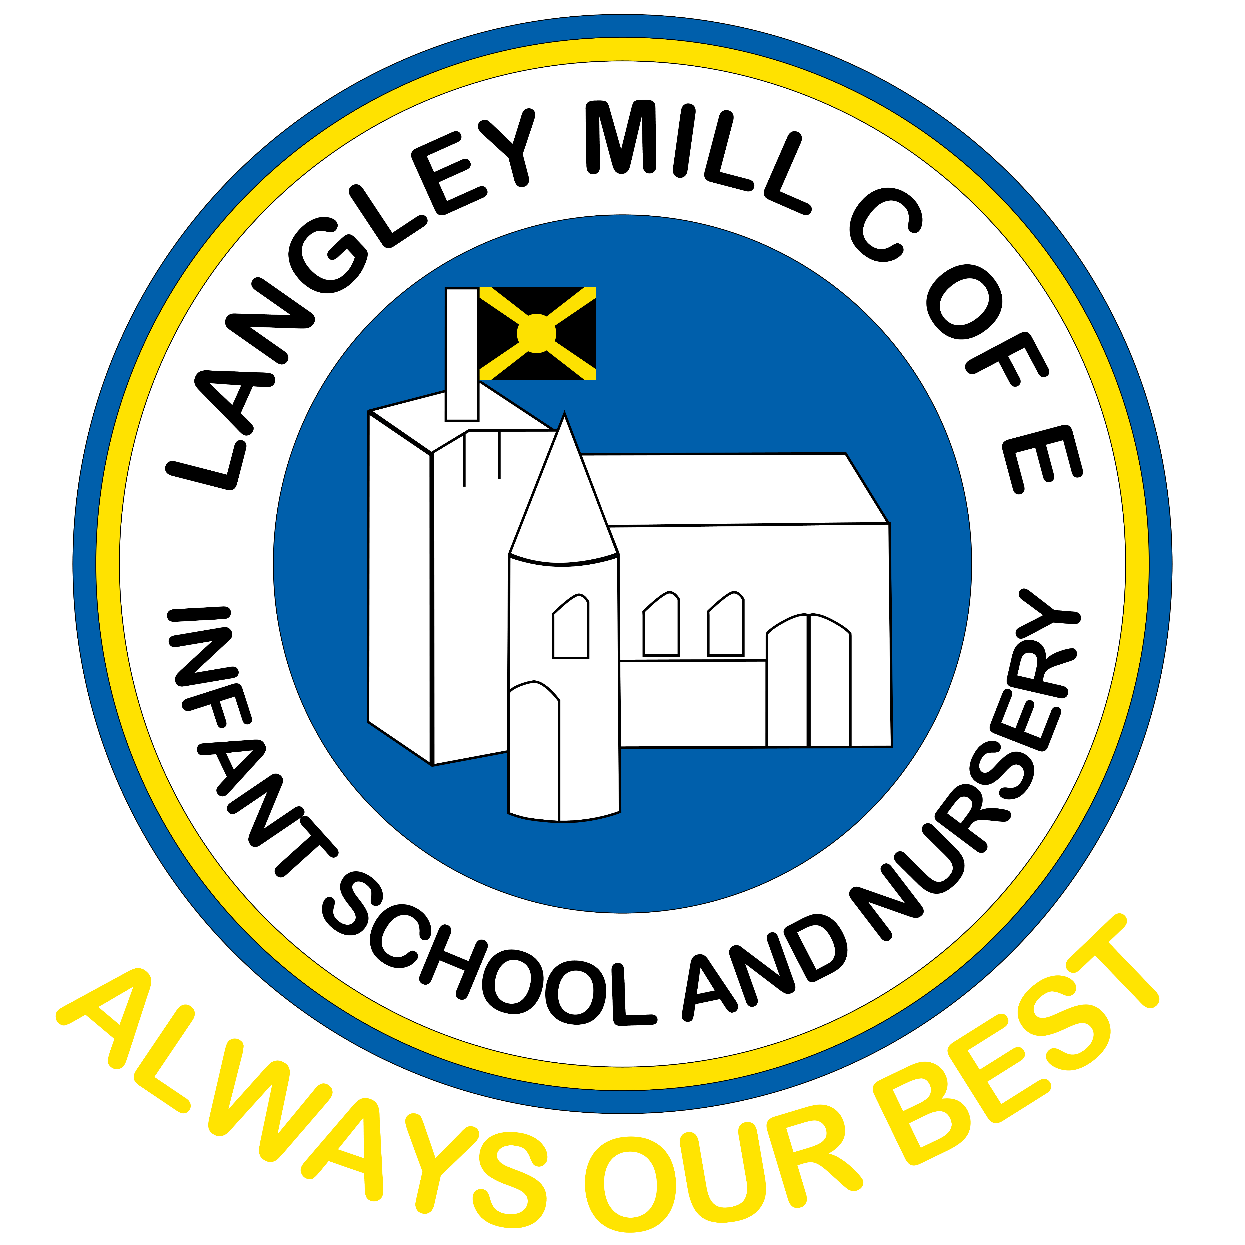
Langley Mill C of E Infant & Nursery News
Autumn 2 2024

We hope you all had a lovely half term break. We are really looking forward to another term of fantastic learning. This term also includes all the Christmas celebrations. Please check the diary dates section and the Christmas Dates section so you don’t miss out on anything.

NON-FICTION NOVEMBER
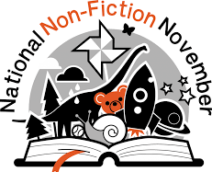
During the whole month of November, we will focus on information and factual books by exploring the many types of non-fiction books that are available for children. This fits in really well with our new topics and the children will really enjoy finding out new facts relating to their topics from the books. It would be lovely to see you sharing non-fiction books at home too. Send photos into your class teachers on dojo and we can print them off for our Library Reading display.

CHILDREN IN NEED –
FRIDAY 15th NOVEMBER


Now more than ever Children in Need is committed to supporting organisations and projects nationwide that help the children who need it the most.
*
This year I asked Pupil Voice to get involved and come up with some ideas for how we could raise money for Children in Need and they then took it back to classes to do a vote. The children have decided to wear pajamas on that day for a £1 donation. They can also wear Pudsey ears if they want to.
*
Please donate via the parent pay link here https://app.parentpay.com/ParentPayShop/Foc/Default.aspx?shopid=15401

(This is also on our Dojo page as a link)

Non- Christmas Diary Dates

Monday 11th November – INSET Day/Open Day (for anyone wanting a look round for a Nursery or Reception place in September 2025)
Monday 11th -Friday 15th November -Anti-Bullying Week
Tuesday 12th November – Odd Socks Day (please send your child in wearing odd socks)
Friday 15th November – Children in Need Dress Up
Tuesday 17th December – Provisional date for Year 2 trip to the Space Centre (more info to follow)
Thursday 19th December– Break Up for Christmas
Friday 20th December – INSET DAY

Monday 6th January 9.00am – Coffee & Cakes Attendance Celebration (you will receive an invite to attend this on the last day of this term…it will be for anyone with 97% or above attendance for this term)

Please see the Christmas Dates section for more dates.

Attendance
I want to say a huge thank you to everyone. We have seen an increase in our attendance last term to put us in line with the national picture. Let’s try and keep that going in Autumn 2.
At the start of the new school year, we saw a massive improvement with our lateness but this has started to slip recently so please try really hard. Just 5 minutes late every day is 25 minutes over a week this soon mounts up a year. If your child is late there is a form for you to fill out on arrival at school.

If your child is absent/late please phone to give reasons (01773 713429). If your child is absent due to medical appointments, which should be taken out of school times whenever possible, please keep appointment cards/letters and again there is a form for you to fill out.

Please remember schools are being asked not to grant any leave of absence unless it is exceptional, and fines have to be issued for any time taken off during term time. Please remember the changes this year around fines (we sent these out last term)

We will be holding our Coffee and Cakes morning on Monday 6th January to celebrate attendance for the Autumn Term. If your child has 97% attendance or above, you will be invited to join us. We will send invites out on Thursday 19th December so please look out for them.
ANTI-BULLYING WEEK – 11th -15th NOVEMBER 23

Anti-Bullying Week is coordinated by the
Anti-Bullying Alliance and this year has the theme
‘Choose Respect’
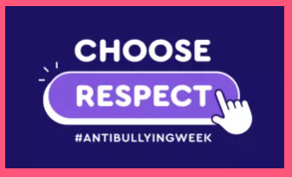

During this special week, there are many things happening:
- The week will begin with ‘Odd Socks Day’ on Tuesday 12th which is supported by CBBC and CBeebies star Andy Day and his band Andy and the Odd Socks. It started in 2017 and has had millions of people join in over the years. Please come to school in odd socks on this day.


- Throughout the week we will use lots of books about being respecting others.
- We will continue to emphasise our Bucket Filling ‘Fillosophy’, encouraging positive behaviours such as being kind and helpful, having good manners, being polite and caring for each other and linking to our value of Respect.
- We will be doing some work on keeping safe online, using Smartie the Penguin to help us.



Communication

Please remember to keep in touch with us via Class Dojo. We will continue to send out message via this platform and share the children’s learning daily with you.



We hope you all have a fantastic term.
From Mrs Gardner and the Langley Mill Team


CHRISTMAS 2024 AT LANGLEY MILL C of E INFANT SCHOOL AND NURSERY

We are very excited to be announcing the special events that will be happening at school in the
run up to Christmas this year.


Thursday 28th November - Christmas Fair
We will be having a Christmas Fair this year in the hall from 3.30pm – 4.30pm. There will be various stalls selling gifts and crafts, a chocolate tombola, lucky dip, book stall, Santa’s Grotto, refreshments and more. If there is anyone who would like a stall, please ring or come and see Mrs Gardner or Mrs Downing to check we don’t already have a stall selling the same. There will be a charge of £5 per table but then any money made on the day will be yours. We are hoping this will be a fantastic community event.


Monday 2nd December – Christmas Jumper Day and Decorating
This is the day that we get Christmas started in school! We all get involved in decorating the
classrooms and spaces around school to start our festivities. Everyone can come to school wearing their Christmas jumpers or clothes.

Week commencing 2nd December – Colours of Christmas Raffle
The staff have made Christmas colour themed hampers filled with all kinds of Christmas
goodies. Tickets will be on sale during this week for £1 each and the winner will be drawn
at the end of the last performance on Thursday 12th December.
Visits to St Andrews Church
We are hoping the children in KS1 will be visiting the church again for Christmas themed activities, but we are waiting to hear if this is possible this year due to a few members of the church who usually organise these either having moved or are unwell.

Week Commencing 9th December – Christmas Productions

Early Year (Nursery & Reception) – ‘We’re going on a Baby Hunt’ Wednesday 11th December at 10am (family viewing-under 3s welcome but please leave the hall if they cry) and Thursday 12th December at 2pm (no under 3s please)

Key Stage 1 (Year 1 & Year 2) – ‘Hey Ewe’ Wednesday 11th December at 2pm (family viewing- under 3s welcome but please leave the hall if they cry) and Thursday 12th December at 5pm (no under 3s please) Please bring Key Stage 1 children back to school for 4.30pm so we can get them changed and ready to perform.

Wednesday 18th December – Christmas Dinner Day/ Jumper Day
We will all have our delicious Christmas Dinner with all the trimmings together in the hall. The usual dietary requirements will be provided for, and your child will still be able to bring their own packed lunch. It is also another opportunity to wear your Christmas Jumper too.

Wednesday 18th December – Carols by Candlelight
We will be hosting Carols by Candlelight again this year in the hall for families to join us for a sing song around the Christmas Tree. This year our school choir club will be leading the singing. We hope you can all join us for this. There will be mince pies and refreshments for sale on the day too. This will be from 3.30-4pm

Thursday 19th December - Christmas Parties
We have decided to have all our Christmas Parties on the same day this year and each class will get time in the hall for party games and dancing and then will enjoy part themed activities in classrooms the rest of the day.
Please come in your favourite (warm) party clothes ready to party!



School closes for the Christmas Break on Thursday 19th December.
We are all back in school on Monday 6th January 2025.

