Langley Mill Church of England Infant School and Nursery – Curious Cotton Mice (Nursery) Medium Term Plan – Spring 1 2023-24
Immersion Event  Winter Woodland Walk | Reading / Book Events  - Winnie the Pooh Day – 18th January  - Nat. Storytelling Week – WC 30.1.25  International Book Giving Day – 14th February |  | Additional Events  - NSPCC Number Day – 7th February  Safer Internet Day – 11th February |  | Parent Partnership Events
Key Texts  1. I love the seasons: Winter  2. The great explorer  3. Percy the post penguin  4. My Grandmas magic recipe  5. Meet the weather  6. How to catch a snowman |  | Winter Wonderland  This topic will the children will be learning all about Winter and why is it so cold. We will also be comparing Winter to the other seasons and discovering which animals live in the snow.  We will be learning all about different countries and places around the world and their Winter! |  | Key Nursery Rhymes  - North wind doth blow  - Rain, rain go away  - DR Foster  - Mulberry bush  - Polly put the kettle on  - Snowflakes
Home Learning  Reading:  - To ensure success, all children are expected to regularly share stories at home. Bedtime is an ideal time to share books to end the day calmly and induce sleep.  - It is helpful not just to read books but point out and talk about text when out and about so children learn that print carries meaning. You can do this with so many things such as road signs, supermarket labels, shopping lists, etc.  - Class DOJO  We will continue to use the Class dojo Families App to communicate with you about learning. All other queries and absence matters must be relayed to the school office. |  | Reminders  Please could we ask for you to try and discourage your child from bringing their own toys from home. We will also encourage this at the beginning on the nursery session. Thank you.  Sessions:  - Morning session time 8:45AM – 11:45AM  - Afternoon session time 12:30PM – 15:30PM  - You can access 15 or 30 hours (if eligibility is met).  Food and Drink:  - Please send your child to school with an empty, capped, named water bottle each Monday morning. This will be returned every Friday for washing over the weekend.  - Any children staying a full day can bring their own packed lunch or access the daily lunch service. This costs £3.25 and you can have a hot lunch or cold sandwich. Any home packed lunches must meet our nutritional, healthy standards.  Clothing:  - Uniform is not statutory in nursery. All children must wear comfortable clothes that are suitable for the weather and can get dirty. We spend lots of time outside in all weathers so sturdy shoes are a must.  - We do not allow the children to wear jewellery, including the wearing of earrings.  - Please send your child to nursery with a spare set of weather appropriate clothing in named bag that. If your child is not yet fully toilet trained they need to have spare nappies, wipes and clothes. The bag will remain in nursery until the end of each term.  - Every child needs a pair of named wellies on their peg in a plastic bag to make the most of our wonderful school grounds in all weather.  - Please ensure your child brings a named water bottle that can remain in nursery.  Staffing:  - The teacher will be covered during Mrs Statham’s maternity leave.  - The teaching assistant will be Mrs Robinson |  | Prior Learning  - Before starting nursery the children should have an idea about where they live and who they live with.  - They should have been encouraged to talk in short, clear sentences and be able to understand and follow simple instructions.  Autumn Prior learning  - They should attempt to put on / take off coats and shoes with some level of independence.  - They will have experienced drinking from cups and tooth brushing.  - They will have taken part in some family celebrations such as birthdays, anniversaries, weddings and parties.  - They will know the name of different weather types and have experienced what they feel like such as rain, wind, sun, fog and maybe snow.
Langley Mill Church of England Infant School and Nursery – Curious Cotton Mice (Nursery) Medium Term Plan – Spring 3 2023-24
Communication and Language  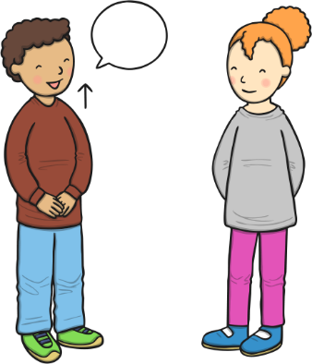  As communicators, the children will be encouraged to listen to the teachers and others for a short period. They will be supported to begin to respond to questions when join in with conversations appropriately and accurately.  The children will partake in an activity known as ‘word of the day’ to enhance and develop the children’s vocabulary. It is important that this term the children are supported to develop and learn new vocabulary and use this to create longer sentences.  The children will be able to follow simple instructions that involve two actions such as “please find your shoes and put them on” | Personal, Social and Emotional Development    As young citizens, the children will be expected to select and use resources that are available for them to use in the classroom independently or with little help. The children will be given a wide range of different activities to choose from that are changed weekly.  The children will begin to carry out given tasks both independently and in a group. This term there will be opportunities to share, take turns and resolve conflicts using jigsaws and educational games such as red dog, blue dog. To begin with this will be supported by adults in the classroom.  The children will also be supported to name, recognise and describe their feelings. This will be taught in planned lessons and in the moment. The children will feel confident to use our calm corner if and when it is needed to support their emotions and feelings.  We will continue use our Bucket Filling books to talk about expected behaviour in nursery, so that all children treat each other and the environment with care. We want to be bucket fillers not bucket dippers! |  |   Physical Development  As movers, the children have a weekly dedicated PE slot, this will take place every Friday. This term our P.E focus is ‘Little Dancers’. This term we are going to focus on both our fine and gross motor skills to enable us to learn lots of new dance routines.  This term there will be a large focus on independence within the nursery. We will be encouraging the children to attend to their own toileting and hygiene needs with little support from the adults.  Within the provision, we will continue to provide a Funky Fingers area with an activity designed to develop the children’s hand control/movements.
Literacy    As readers, we will work on pre-reading skills. This term we will have a focus on rhythm and rhyming and alliteration, following ideas given on the Letters and Sounds Scheme (Phase 1). The children will be given the opportunity to explore different objects with the same initial sounds throughout the term. We will also be focusing on hearing initial sounds in a variety of different words and playing games such as silly soup, bingo and hear the sound, say the sound to assist our development. These games will be provided through taught group sessions and independent learning time.  We will read lots of key texts related to our ‘Wonderful Winter ’ topic and use these to sequence and investigate events of the stories. The children will be encouraged to use the vocabulary from the story books provided alongside friends and during the independent learning.  As writers, we will develop the children’s fine motor skills be providing them with a funky finger area within the classroom. The children will be supported to use scissors, string, tweezers and straws to develop their cutting, threading, pinching and poking skills. We will continue to encourage good pencil grip with an outcome of writing  some on their own name. |  | Mathematics  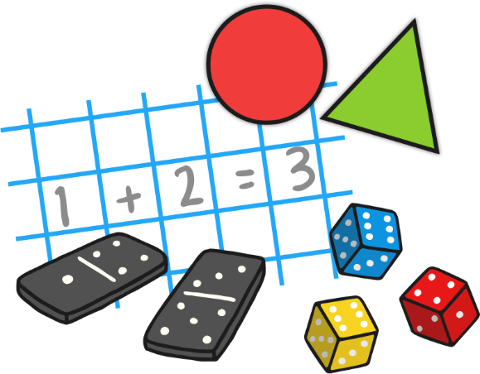  As mathematicians, the children will learn how to confidently recite numbers to 10 and beyond.  This term we will have a big focus on numbers 3-5. The children will participate in a daily, small group activity where they will be supported to use their mathematical skills such as counting on, showing amount on fingers, seeing different amounts in many different ways. This will also be replicated in the continuous provision.  Within the provision, the children will have lots of opportunities to compare different weights, lengths and capacities through activities such as making a measuring wall for the children’s heights, lots of water/ice-based experiments and baking.- 3 triangle 4 squares 2d shapes  The children will continue to develop their awareness of time, each morning the children will change the day, date and month, during this time the children will begin to discuss upcoming events that are happening that week such as birthdays, activities throughout the day or week.
  Understanding the World  As historians, the children will be learning all about the season Winter. We will investigate how the weather changes. We will learn all about what is clothing is appropriate and what is not and go on lots of winter walks to explore the cold.    As geographers, the children will be looking at the globe and search for other counties that are snowy. We will be investigating the Arctic and Antarctica and delving into what life is really like there, how they are similar and how they are different. We will also explore what animals live there and how they survive.    As scientists, the children will explore different materials and how they can change such as ice and water! We will also begin to explore all about the ice caps melting in the polar regions and discuss how we can help as community.    As theologians, the children develop positive attitudes about the differences between people. As a Church School, they will learn our nursery prayers which are recited on entry and at home time. Throughout the term we will seize opportunities to talk about life events.  The children will be given many opportunities to listen and learn new music including a variety of songs relating Winter and Winter animals. Ask to see our penguin dance! |  |       Expressive Arts and Design.As artists, the children will be focusing on printing this term. The children will be provided with lots of resources to print with winter colours.  As musicians, the children will be provided with musical instruments in the classroom, they will be expected to tap out rhythms, tap to the beat and dance along to the rhythms they make.  The children will also be provided with a variety of music and songs to listen, learn and dance that link to our winter topic.  We will continue access Charanga’s Song Collection to choose a range of well known, favourite and number songs to support our curriculum and their Listening Activities, which is a collection of stories and listening examples designed especially for younger children. We will also select some of Charanga’s Musical Activities to develop the children’s musical and general skills. These include listening activities, musical games, singing and playing instruments.  As creators, the children will continue to develop their imaginations, role playing in our Ice Cafe home corner and through other opportunities such as dressing up, using small world characters and accessing a range of props and open-ended resources.

