Langley Mill Church of England Infant School and Nursery – Dazzling Dormice (Reception) Medium Term Plan – Autumn 2 2023-24
Immersion Event:  - Community Visitors-we are hoping to invite the Fire Brigade and Police into school. | Additional Event:  Bonfire Night - 5.11.24  Odd sock Day 4.11.24  Remembrance Day - 11.11.24  CIN – WC 15.11.24  AB Week – WC 11.11.24  Winter Solstice - 21.12.24 |  | Reading / Book Event:  - National Non-Fiction November  (Bonfire Night, Remembrance, Winter, Christmas) |  | Parent Partnership Events  Christmas Concert
Key Texts  1. Super tato  2. Ten Rules of Being a Superhero - Deb Pilutti.  3. Real superheroes  4. You can’t call an Elephant in an emergency  5.A superhero like you  6. the busy nativity  7. Dream snow eric carle |  | Are you a superhero?  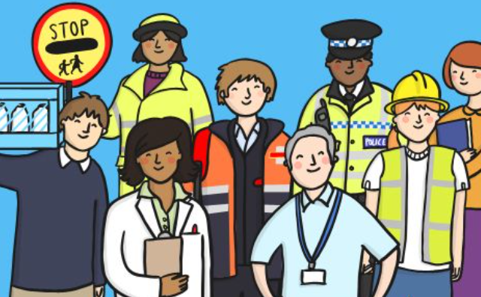  This topic was chosen to further develop the children’s understanding of members in their local community, who is familiar to them and how they help us. Children will also learn that some places are special to members of their community, where these people work and what is special about these buildings. |  | Key Rhymes  1. 5 little fireman  2. Miss Polly  3. Early years song- people who help.  4. Superhero song  5. Twinkle, Twinkle Christmas star  6. Away in a manger  7. When Santa got stuck up the chimney  (plus extra Christmas songs for concert).
Home Learning  Reading:  - To ensure success, all children are expected to read at least 5 times per week at home.  - Home reading needs to be recorded by an adult in the blue reading diary.  - Entries will be counted Thursday to Thursday in order to earn a stamp on the church tower reward chart and be rewarded in Friday’s Celebration Worship. You will be invited to this if your child has won an award (Thursday evening via Dojo App). |  | Reminders  Food and Drink:  - Please send your child to school with an empty, capped, named water bottle each Monday morning. This will be returned every Friday for washing over the weekend.  Uniform / Clothing:  - All children must wear the correct active uniform (plain white t-shirt/polo shirt, plain royal blue sweatshirt/cardigan/jumper/ fleece, plain black joggers/ skirt/leggings, plain black shoes / trainers – no colours or logos except the school badge.  - Every child needs a pair of named wellies on their peg in a plastic bag to make the most of our wonderful school grounds in all weather and plain black pumps for PE (to be kept in a drawstring bag in school to avoid wet/mud in the hall).  Staffing  - The teachers will be Mrs Harris  - The teaching assistants will be Mrs Hughes (All day) Mrs Clarke (AM) Mrs Summers (PM). |  | Prior Learning  - In nursery, the children made connections between features of their family and that of other families. They developed positive attitudes about the differences between people and gained an awareness of different cultures. They started to think about the season of winter, noting key changes that happen at this time of year.  This term in Reception we will be learning...  - In reception, the children will learn all about different people in our local community, what jobs they do and how they help us. They will name and describe people who are familiar to them and find out about community figures. They will also compare and contrast characters from stories related to people who help us and the jobs they do. They will also explore the natural world around them through songs and rhymes.  - In addition they will recognise that people have different beliefs and celebrate special times in different ways, with a focus on how Christians celebrate Christmas.
Langley Mill Church of England Infant School and Nursery – Dazzling Dormice (Reception) Medium Term Plan – Autumn 2 2022-23
Communication and Language  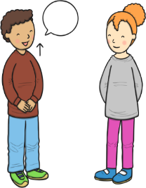  As communicators, the children will share their ideas across all areas of learning. They will learn new vocabulary linked to specific job roles e.g. fire engine, siren, hose. They will ask questions during visits from community figures to gain more understanding.  ~  They will engage in daily story time sessions with books related to the topic being taught, including non-fiction books. They will also listen carefully to a range of rhymes and songs.  ~  The children will continue to develop good listening skills, especially during visits from community figures.  ~  They will be encouraged to talk in complete sentences when discussing people who help us, the jobs they do and their role in the local community. The children will develop social phrases linked to our topic during their role play. | Personal, Social and Emotional Development  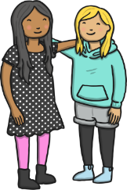  As young citizens, the children will be encouraged to listen to each other and visitors from the local community.  ~  Throughout the term we will focus on identifying and describing a range of feelings, using lots of stories to prompt discussions.  ~  The children will continue to work on taking turns with their peers during groups activities and free choice time.  ~  They will discuss the challenges that people in the community face on a daily basis and how they deal with this including mindfulness and breathing techniques.  ~  The children will continue to develop their own personal hygiene with a focus on thorough hand washing. We will discuss germs and how to stay healthy during our discussions around doctors and nurses.  ~  They will learn about healthy eating and how this helps our bodies and brains stay healthy. |  | Physical Development    As sportspeople, they children practise negotiating spaces and moving skilfully around the indoor and outdoor areas. To develop specific game skills, they will follow the AVSSP DTF PE scheme ‘Invasion games’ Unit. Through this, lots of activities will be used to help them develop understanding movement and skill, affects of exercise on the body and understand tactics. The skills they will develop include dribbling, passing, shooting and receiving.  ~  As gymnasts, the children will follow the AVSSP DTF Gymnastics scheme and will spend time practising different ways of travelling along various pathways.  ~  The children will also be practising fastening and zips as they put on their coats, waterproofs, overalls and wellies as we enjoy the outdoor environment all year round.  ~  They will also be encouraged to use cutlery and other one-handed equipment, including scissors.  ~  The children will practise all of their physical skills by taking part in Squiggle While You Wiggle lessons and daily Funky Finger activities which include threading, tweezers and cutting skills.
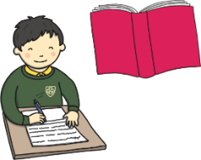  Literacy  As readers, the children will continue to take part in daily 20-30-minute Little Wandle phonics lessons. Through these lessons the children will learn single sounds which link to those in their reading books. They will continue to learning the skill of saying sounds in a short word to hear the word and read it. Children will also practise reading keywords by sight including ‘is, a, the, I, for, of, are, he was, said, all, we’. November is national non-fiction month. Children will be learning facts about bonfire night, remembrance day and learning information about people who help us through non-fiction books.  ~  As writers, the children will continue to learn how to form some lower case and capital letters correctly. They will start to be able to spell simple words using the sounds they have learnt in phonics and learn how to spell key sight words. The children will use their phonics knowledge to write simple captions and labels to match pictures and some will begin to write simple 2- and 3-word sentences. |  | 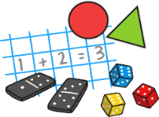  Mathematics  As mathematicians, the children will follow the White Rose Scheme.  ~  In number children will identify representations of 1,2 and 3. They will continue to work on subitising as they identify numbers without counting. They will match numerals to quantities and count objects accurately with 1-1 correspondence. Children will learn about 1 more and 1 less through counting songs, stories and using objects. They will learn that 2 and 3 are made up of smaller numbers e.g. 3 is made up of 1 and 1 and 1 or 2 and 1  ~  During shape, space and measure lessons, the children will learn about 2D shapes – circle, triangle, square and rectangle. They will identify shapes in their environments and begin to use mathematical language to describe them. They will also learn about positional language e.g. next to, behind, on top of. They will follow positional language instructions and begin to use appropriate language to describe where an object is. Finally the children will learn about time as we sequence familiar events and explore timers.
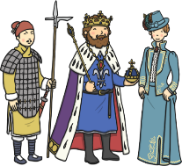  Understanding the World  As historians, the children will learn about how jobs have changed and use photographs to look at changes e.g. how has a fire engine changed.    ~    As geographers, the children will learn that there are many different types of jobs. They will look at where people who help us work and learn what is special about these buildings. They will use simple maps and aerial photographs to find where local buildings are e.g. our local police station and fire station.  ~  As scientists, the children will learn more about the effect of the changing seasons around them as we move into winter. They will explore the world around them and learn about different types of weather including frost and ice. They will learn about animal behaviours during Autumn. | 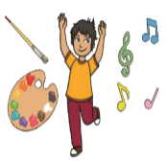  Expressive Arts and Design  As artists, the children will look at a variety of portraits of people who help us. They will carefully paint portraits of local community heroes looking carefully at uniform etc. The children will use also make poppies for rememberance day and create winter and Christmas pictures.  ~  As musicians, the children will follow the Charanga music scheme, ‘My stories’ unit of work. Through these lessons they will learn how to follow the beat in a song and join in with rhymes. They will use their voice as an instrument and perform to an audience.  ~  As dancers, the children will follow the BBC Let’s Move ‘People who help us’ unit. In these lessons’ children will learn about different community heroes including people in school, hospital helpers, bus drivers and fire fighters. They will practise travelling through space in time to music adjusting their speed and changing into different positions |  |   Religious Education  As theologians, the children will follow Derbyshire’s Agreed Syllabus to think about which people are special to them and why. They will also learn about who is special to Christians.  ~  Children will learn that people have different beliefs and celebrate special times in different ways.  ~  All children will also attend daily whole school Collective Worship in the hall focused on our vision “Always our best for God, each other and ourselves” and our Four Langley Mill Foundations: Aspire, Learn, Respect, Serve.  ~  Children will learn all about advent and the nativity story through collective worship and RE lessons.  ~  At the end of the term we will all celebrate this special time of year with a Christmas play.

