Langley Mill Church of England Infant School and Nursery – Curious Cotton Mice (Nursery) Medium Term Plan – Spring 2 2024-25
Immersion Event:  Chicks! | Additional Event:  Mother’s Day school TBC  British Science Week – WC 7.3.24  Spring Equinox - 20.3.25  Red Nose Day 21.3.24 |  | Reading / Book Event:  World Book Day - 6.3.24  World Storytelling Day - 20.3.24 |  | Parent Partnership Events  - Mother’s Day Event – tbc  Easter Concert tbc
Key Texts  1.How to look after your pet dinosaur  2.Not that PET!  3. What the ladybird heard  4. Farmyard Hullabloo  5.Three Little Pigs  6. Non-fiction chick book |  | Who lives in an egg?  This topic will the children will be learning all about different animals, their habitats and how to look after them. We will be investigating what animals what would make good pets and why. |  | Key Nursery Rhymes  1. Dinosaurs go STOMP  2. Sleeping Bunnies  3. Baa Baa Black Sheep  4. Dingle Dangle Scarecrow  5.Old McDonald  6. Chick, chick, chick, chicken.
Home Learning  Reading:  - To ensure success, all children are expected to regularly share stories at home. Bedtime is an ideal time to share books to end the day calmly and induce sleep.  - It is helpful not just to read books but point out and talk about text when out and about so children learn that print carries meaning. You can do this with so many things such as road signs, supermarket labels, shopping lists, etc.  Dojo  - We will continue to use the Dojo App to communicate with you about learning. All other queries and absence matters must be relayed to the school office. |  | Reminders  Please could we ask for you to try and discourage your child from bringing their own toys from home. We will also encourage this at the beginning on the nursery session. Thank you.  Sessions:  - Morning session time 8:45AM – 11:45AM  - Afternoon session time 12:30PM – 15:30PM  - You can access 15 or 30 hours (if eligibility is met).  - Those that access 30 hours must pay an additional £3 to cover the lunch period. Lunch is £2.40 extra.  Food and Drink:  - Please send your child to school with an empty, capped, named water bottle each Monday morning. This will be returned every Friday for washing over the weekend.  - Any children staying a full day can bring their own packed lunch or access the daily lunch service. This costs £2.40 and you can have a hot lunch or cold sandwich. Any home packed lunches must meet our nutritional, healthy standards.  Clothing:  - Uniform is not statutory in nursery. All children must wear comfortable clothes that are suitable for the weather and can get dirty. We spend lots of time outside in all weathers so sturdy shoes are a must.  - We do not allow the children to wear jewellery.  - Please send your child to nursery with a spare set of weather appropriate clothing in named bag that. If your child is not yet fully toilet trained they need to have spare nappies, wipes and clothes. The bag will remain in nursery until the end of each term.  - Every child needs a pair of named wellies on their peg in a plastic bag to make the most of our wonderful school grounds in all weather.  - Please ensure your child brings a named water bottle that can remain in school.  Staffing  - The teacher will be Mrs Harris  - The teaching assistants will be Mrs Hughes (all day)  Mrs Clarke (am) Mrs Summers (pm) |  | Prior Learning  - Before starting nursery the children should have an idea about where they live and who they live with.  - They should have been encouraged to talk in short, clear sentences and be able to understand and follow simple instructions.  Autumn Prior learning  - They should attempt to put on / take off coats and shoes with some level of independence.  - They will have experienced drinking from cups and tooth brushing.  - They will have taken part in some family celebrations such as birthdays, anniversaries, weddings and parties.  - They will know the name of different weather types and have experienced what they feel like such as rain, wind, sun, fog and maybe snow.  Spring 3 Prior Learning  - The children will be able to name and talk in detail about the different seasons.  - They will have experienced many different experiments that include ice, water and temperature change.
Langley Mill Church of England Infant School and Nursery – Curious Cotton Mice (Nursery) Medium Term Plan – Spring 3 2022-23
Communication and Language  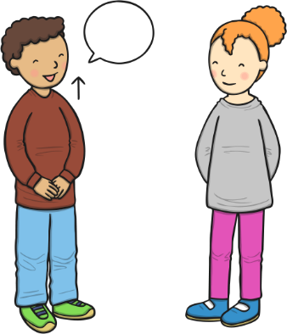  As communicators, the children will have developed their listening skills and will be encouraged to do so for a longer period of time.  The children will continue to develop their listening and communication skills by joining in with conversations appropriately and accurately. It is important that this term the children are support to develop and learn new vocabulary and use this to create longer sentences.  The children will begin to use the new question all to develop and extend their language. They children will be expected to be able to understand and ask why questions in terms of investigations. To support this, there will be a planned ‘question time’ each Monday.  The children will be able to follow simple instructions accurately that involve two actions such as “please find your shoes and put them on”. | Personal, Social and Emotional Development    As young citizens, the children will be expected to select and use resources that are available for them to use in the classroom independently. The children will be supported by the adults to use the outdoor equipment from the shed. There is always a range of different activities for the children to select from whilst in Nursery, they will be given opportunity throughout the day to choose from both inside and outside activities.  The children will continue to carry out given tasks both independently and in a group. This term there will be opportunities to share, take turns and resolve conflicts using a variety of traditional games. The adults within nursery will continue to support the children throughout.  The children will also be supported to name, recognise and describe their feelings. This will be taught in planned lessons and in the moment. The children will feel confident to independently use our calm corner if and when it is needed to support their emotions and feelings.  We will continue use our Bucket Filling books to talk about expected behaviour in nursery, so that all children treat each other and the environment with care. We want to be bucket fillers not bucket dippers! |  |   Physical Development  As movers, the children have a weekly dedicated PE slot, this will take place every Thursday. This term our P.E focus is ‘Jungle journey’. This story will take the children on a journey that will require them to move in lots of different ways. E.g. slither like a snake. Swing like a monkey.  There will be a focus on ‘match the movement’ games outside. This will include games such as tag, what’s the time Mr wolf, through the hoop.  We will continue to focus on independence within the nursery. We will be encouraging the children to attend to their own toileting and hygiene needs with little support from the adults. This will include going to the toilet and washing their hands independently.  Within the provision we will continue to provide a Funky Fingers area with an activity designed to develop the children’s hand control/movements. During this term the children will begin to participate in ‘Dough Disco’ which is a group taught session that focuses on getting their fingers moving.
Literacy    As readers, the children will continue to work on their pre-reading skills.  This erm we will be focusing on aspect 5 and 6. During this aspect the children will be delving more into initial sounds, distinguishing between different vocal sounds, including oral blending and segmenting, following ideas given Little through the Little Wandle Scheme.  The children will continue to be provided phonics related games in independent learning as well as group taught.  We will read lots of key texts related to the ‘Who lives in an egg?’ topic and use these to sequence and investigate events of the different stories. The children will be encouraged to use a range of vocabulary from our weekly books and topic-based books provided in our reading area and areas of learning to aid their play during independent learning.  As writers, we will develop the children’s the children’s fine motor skills area within the classroom. The children will continue to develop their cutting, threading, pinch and zipping skills through planned activities. Such as making Mother’s Day and Easter cards.  The children will be supported to use good pencil grip when writing sounds they hear and see in words. |  | Mathematics  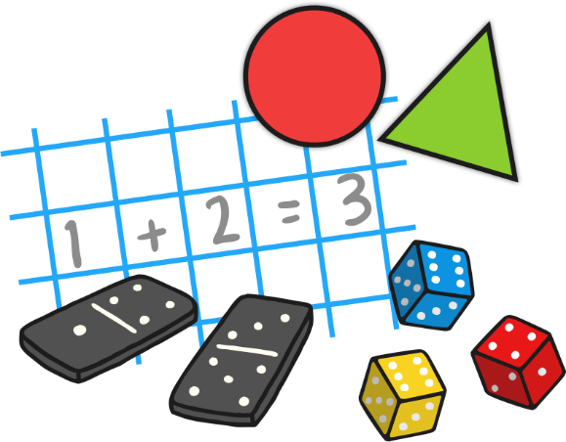  As mathematicians, the children will learn how to confidently recite numbers to 10 and beyond.  This term we will have a big focus on numbers 0-7. The children will participate in a daily, small group activity where they will be supported to use their mathematical skills such as counting on, showing amount on fingers, seeing different amounts in many different ways. This will also be replicated in the continuous provision.  The children will be learning all about 2D and 3D shapes during this term. The children will be given the opportunity to investigate a variety of different shapes such as squares, circles, rectangle and squares. We will then be moving on to cubes, cuboids, spheres and pyramids. This will be replicated in the continuous provision.  The children will be given lots of opportunities to compare different weights, lengths and capacities through more outdoor based activities this term. There will be water, weights, jugs, pots, pans, measuring sticks within the continuous provision to support their maths skills.
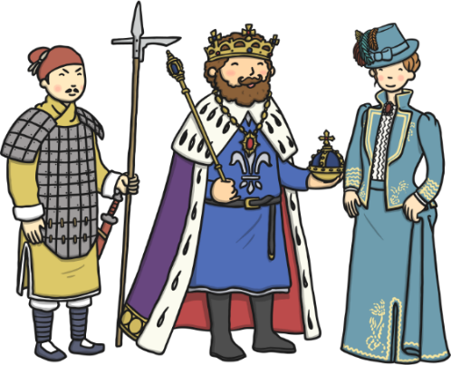  Understanding the World  As historians, the children about investigate different pets, what animals would make good pets and what pets we have in our family homes. The children will begin to understand, respect and care for different animals. Together, will be discussing Zoo’s and national parks and the effects these have on the animals.      As geographers, the children will learn about different animals from all over the world and their habitats. The children will discuss whether these animals are mammals, birds, fish, reptile, amphibians or insects and their difference.  As scientists, the children will learn all about the different roles people have when caring for animals/ For example the role of a vet, shop keeper, and us as pet owners.  The children will develop an understanding of Mother’s and their babies alongside how the look after them.    As theologians, the children develop positive attitudes about the differences between people.  As a Christian school the children will be give the opportunity to learn all about the Easter Story. During this time, the children will opportunity to look at different religious artefacts, dress up as different characters from the story and act out the different scenes.  The children will be given many opportunities to listen and learn new music including a variety of songs related to Easter and learn them ready for our Easter Concert. |  | 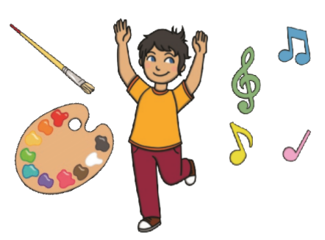  Expressive Arts and Design  As artists, the children will be building a 3D sculpture. This term the children will be provided with junk modelling to build model pets and their homes.  We will also be sculpting a 3D cross to accompany the small crosses we will designing as part of a display for easter.      As musicians, the children will be provided with musical instruments in the classroom, they will be expected to tap out rhythms, tap to the beat and dance along to the rhythms they make.  The children will also be provided with a variety of music and songs to listen, learn and dance that link to Easter and our termly topic.  We will continue access Charanga’s Song Collection to choose a range of well known, favourite and number songs to support our curriculum and their Listening Activities, which is a collection of stories and listening examples designed especially for younger children. We will also select some of Charanga’s Musical Activities to develop the children’s musical and general skills. These include listening activities, musical games, singing and playing instruments.  As creators, the children will continue to develop their imaginations, role playing in our Vets and through other opportunities such as dressing up, using small world characters and accessing a range of props and open-ended resources.

