Langley Mill Church of England Infant School and Nursery – Curious Cotton Mice (Nursery) Medium Term Plan – Spring 2 2022-23
Immersion Event  - Classroom immersion – ice cream shop, seaside role play, pirates role play, seaside day. | Additional Event:  - Empathy Day 9.6.25  - Healthy Eating week WC 10.6.25  - Fathers Day – 15.6.25  - Summer Solstice – 21.6.25  - Seaside/pirate day – TBC |  | Reading / Book Event:  National Share a Story month |  | Parent Partnership Events  Woodland Adventure
Key Texts  1. The snail and the whale – Julia Donaldnson  2. We all go travelling by  3. Pirates love underpants – Claire Freedman  4. Pirate pete and his smelly feet.  5. Maisy goes on holiday – Lucy Cousins  6. Somebody swallowed Stanley  7. I can eat a rainbow (healthy eating week) |  | Are we there yet?  Our topic this term is ‘Are we there yet?’. We will be learning all about Summer, the seaside, the deep blue sea and pirates!  We will also be talking all about our transition to reception. We will be discussing how we will be getting ready for our next big chapter, how it might make us feel and then celebrating with a party!   |  | Key Nursery Rhymes  - Bobby Shafto  - When I was 1  - The Big ship sales  - There’s a hole  - I’m a pirate  - Row, row, row your boat  - A sailor went to sea
Home Learning  Reading:  - To ensure success, all children are expected to regularly share stories at home. Bedtime is an ideal time to share books to end the day calmly and induce sleep.  - It is helpful not just to read books but point out and talk about text when out and about so children learn that print carries meaning. You can do this with so many things such as road signs, supermarket labels, shopping lists, etc.  Dojo  - We will continue to use the Seesaw Families App to communicate with you about learning. All other queries and absence matters must be relayed to the school office. |  | Reminders  Please could we ask for you to try and discourage your child from bringing their own toys from home. We will also encourage this at the beginning on the nursery session. Thank you.  Sessions:  - Morning session time 8:45AM – 11:45AM  - Afternoon session time 12:30PM – 15:30PM  - You can access 15 or 30 hours (if eligibility is met).  - Those that access 30 hours must pay an additional £3 to cover the lunch period.  Food and Drink:  - Please send your child to school with an empty, capped, named water bottle each Monday morning. This will be returned every Friday for washing over the weekend.  - Any children staying a full day can bring their own packed lunch or access the daily lunch service. This costs £2.30 and you can have a hot lunch or cold sandwich. Any home packed lunches must meet our nutritional, healthy standards.  Clothing:  - Uniform is not statutory in nursery. All children must wear comfortable clothes that are suitable for the weather and can get dirty. We spend lots of time outside in all weathers so sturdy shoes are a must.  - Please send your child to nursery with a spare set of weather appropriate clothing in named bag that. If your child is not yet fully toilet trained they need to have spare nappies, wipes and clothes. The bag will remain in nursery until the end of each term.  - Every child needs a pair of named wellies on their peg in a plastic bag to make the most of our wonderful school grounds in all weather.  - Please ensure your child brings a named water bottle that can remain in nursery.  Staffing:  - The teacher will be Mrs Harris .  - The teaching assistants will be Mrs Hughes and Miss Forst  - AM: Mrs Clarke PM: Mrs Summers. |  | Prior Learning  - Before starting nursery the children should have an idea about where they live and who they live with.  - They should have been encouraged to talk in short, clear sentences and be able to understand and follow simple instructions.  Autumn Prior learning  - They should attempt to put on / take off coats and shoes with some level of independence.  - They will have experienced drinking from cups and tooth brushing.  - They will have taken part in some family celebrations such as birthdays, anniversaries, weddings and parties.  - They will know the name of different weather types and have experienced what they feel like such as rain, wind, sun, fog and maybe snow.  Spring Prior Learning  - The children will be able to name and talk in detail about the different seasons.  - They will have experienced many different experiments that include ice, water and temperature change.  - The children will be able to name and talk about some of the different animal groups and what makes them that kind of animal.  - The children will be able to discuss different animals from around the world and if they make a good pet.  Summer Prior Learning  - During the Summer 5 the children investigated planting, growing and picking their flowers, vegetables and fruit in the nursery garden.  - The children developed an understanding of many different life cycles, including flowers, insects and different types of animals.  - The children have begun to understand and use their phonetical knowledge to support their writing.  - The children ae begun practicing writing for purpose using topic based words from around the classroom.
Langley Mill Church of England Infant School and Nursery – Curious Cotton Mice (Nursery) Medium Term Plan – Summer 6 2022-23
Communication and Language  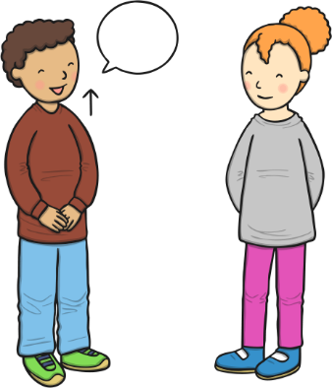  As communicators, the children will have developed their listening skills and will be encouraged to do so for a longer period of time.  The children will continue to develop their listening and communication skills by joining in with conversations appropriately and accurately. The will begin to explain, describe, recount and retell stories and real life events that are happening in and around nursery. The children will be supported to use connectives to link their sentences together and encouraged to use the correct tense. For example, I sat on the carpet rather than I sitted on the carpet.  They children will be expected to be able to understand and ask why questions in terms of investigations. To support this, there will be a planned ‘question time’ each Monday.  The children will be able to follow simple instructions accurately that involve two actions such as “please find your shoes and put them on”. | Personal, Social and Emotional Development  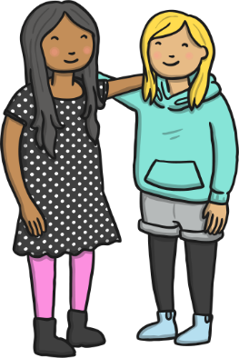  As young citizens, the children will be expected to select and use resources that are available for them to use in the classroom independently. They will be given the opportunity to make-up and reinvent games and confidently discuss together as a team to achieve their end goal. This will be supported through indoor and outdoor activities.  The children will continue to carry out given tasks both independently and in a group. This term there will be opportunities to share, take turns and resolve conflicts using a variety of traditional games. The adults within nursery will continue to support the children throughout.  The children will also be supported to name, recognise and describe their feelings in an appropriate and mature manner.  This term, to support independence, the children have been provided with an emotion regulation corner  We will continue use our Bucket Filling books to talk about expected behaviour in nursery, so that all children treat each other and the environment with care. We want to be bucket fillers not bucket dippers! |  |   Physical Development  As movers, the children have a weekly dedicated PE slot, this will take place every Friday. This term our P.E focus is ‘Sports Day’. The children will be partaking in a range of different activities that will build their sportsmanship, support for each other and their ability to work as a team. During their sports day practice there will be a focus on balance, throwing and running.  There will be a focus on throwing, catching, and bat and games. The children will be given an array of resources such as balls, bats, streamers and frisbees in the nursery garden to choose from to develop these skills. The children will be given the opportunity to develop their balancing skills through the choice of bikes, scooters, cars and stilts.  The children will be given the opportunity to investigate the fruit and vegetables we have grown in the garden. We will be exploring different ways to cook, eat and try them.  Within the provision we will continue to provide a Funky Fingers area with an activity designed to develop the children’s hand control/movements. During this term the children gain confidence in using one-handed tools and have confident grip when some control when using them. This term we will focus on writing letters of our name in the correct order and writing CVC words.
Literacy  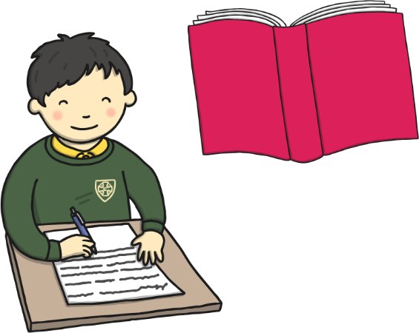  As readers, the children will continue to work on their pre-reading skills.  The children will begin to learn some lesson and games from the Sounds-Write Scheme that is followed throughout the school. The children will begin to have a sound recognition of the sounds SATPIM. They will begin to use their phonetical knowledge to hear, blend, segment, build and create simple CVC words. For example, s-i-t.  We will also recap the Letters and Sounds Scheme to ensure a sound consolidation of the previous aspects.  The children will be able to talk about stories that we have heard such as pirates love underpants, Maisy goes on holiday, avocado baby and many more; and use this to aid their learning and play. The children will be provided a language rich environment with topic-based from books, word of mouth and class research words to support their vocabulary during this term.  The children will be provided with simple social stories that will aid them with their transition over to reception.  As writers, the children will be able to independently write their name ready for starting reception. They will use their phonetical knowledge to orally segment single sound CVC works and write some letter sounds they hear with good formation.  The children will use the language rich environment and ques from around the classroom to support them to apply print knowledge to their writing skills. |  | Mathematics  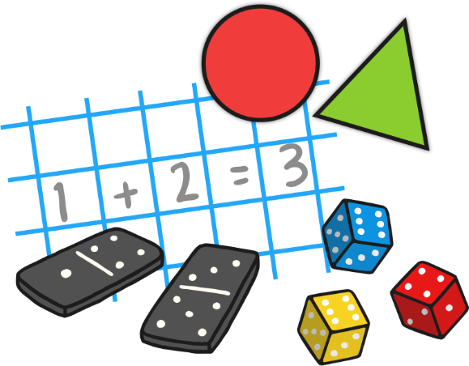  As mathematicians, the children will be able to subitise numbers to 3 without individually counting them and continue to identifying numbers up to 10. The children experiment with symbols and marks and begin to solve real world mathematic problems with numbers up to 5.  The children will understand position through words alone, describe familiar routes and locations by using words such as behind and in-front. This will be done through making a variety of different maps for around our nursery area. This will include a pirate map this term!  The children will explore and identify patterns around them and partake in making and correcting ABAB patterns in and around the classroom. For example, stick, rock, stick, rock.  There will be a lot of recapping and repetition of the previous terms to ensure that their knowledge is consolidated and that they are confident in all areas of mathematics.  All our learning through-out the term will be replicated in the continuous provision; this will also consolidate their mathematical learning.  The children will be given lots of opportunities to compare different weights, lengths and capacities through more outdoor based activities this term. There will be water, weights, jugs, pots, pans, measuring sticks within the continuous provision to support their maths skills.
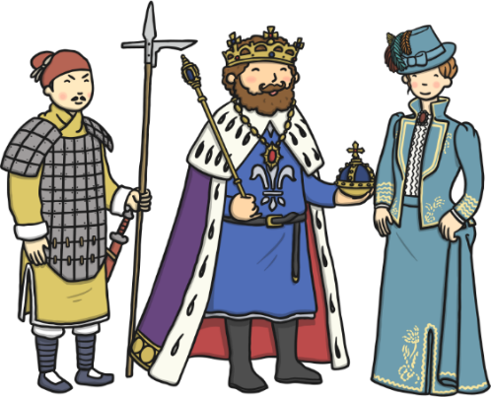  Understanding the World  As historians, this term the children will be exploring, investigating and learning all about pirates. We will discuss our prior knowledge of pirates, what we know now and look at different artefacts that relate to pirates.    As geographers, we will explore the different countries across the world that are holiday destinations. We will also be investigating the different seas and the animals that live in them.  ----    As scientists, the children will learn all about how to plant, grow and care for different seeds and bulbs. We will investigate the growth, change and decay of them as we make our way through the term. We will also be planting our own fruit and vegetable patch in nursery so we can taste our own produce.  We will also investigate the key features of some insect’s life cycles alongside actually viewing this first hand.  As theologians, the children develop positive attitudes about the differences between people.  As a Christian school the children will be give the opportunity to learn all about different religious stories from the bible and compare them to our own values as small humans.  The children will be given many opportunities to listen to new music. This term within the calm area we will be providing the children with a variety of different classical music, we will then discuss how the different songs made us feel, think and if we liked or disliked it. |  | 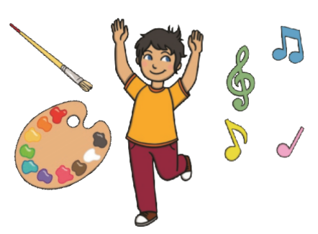  Expressive Arts and Design  As artists, the children will be creating lots of natural pictures using items and treasures we find in the garden. We will use these to create group and individual collages.  We will also be exploring and comparing illustrations from both Eric Carle and Louis Elhert story books and recreating these using similar designs.  As musicians, the children will be provided with musical instruments in the classroom, they will be expected to tap out rhythms, tap to the beat and dance along to the rhythms they make.  We will continue access Charanga’s Song Collection to choose a range of well known, favourite and number songs to support our curriculum and their Listening Activities, which is a collection of stories and listening examples designed especially for younger children. We will also select some of Charanga’s Musical Activities to develop the children’s musical and general skills. These include listening activities, musical games, singing and playing instruments.  As creators, the children will continue to develop their imaginations, role playing in our Vets and through other opportunities such as dressing up, using small world characters and accessing a range of props and open-ended resources.

