Langley Mill Church of England Infant School and Nursery – Curious Cotton Mice Nursery Medium Term Plan – Autumn 1 2025-26
Marvellous Me!  This topic was chosen as it is important for the children to have a really good sense of who they are as an individual and what makes them, them! We will also be investigating who is in their family and what makes their family special to them.  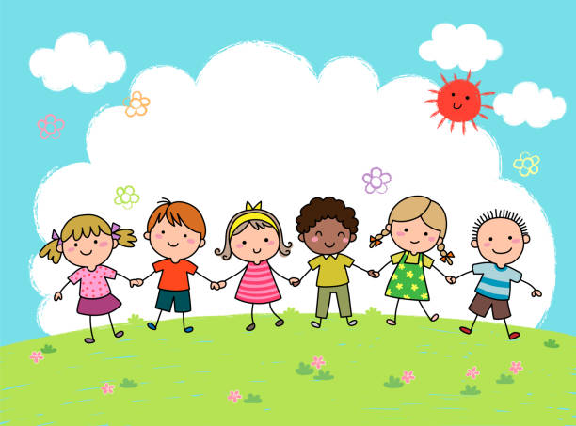  It is important for the children to know why they are special and what makes them unique. They need to know how people are different and similar, starting with those familiar to them then extending to other families in a wider context. The children also need lots of freedom and choice to practise a range of skills and develop knowledge across many areas. | Immersion Events  - Talent Show!  Parent Partnership Events  - Parent consultations – 14, 15, 16.10.25  - Harvest Event in the Early Years – W/C 20.10.25  Reading / Book Events  - Roald Dahl Day - 13.9.25  - National Poetry Day - 2.10.25  - National Libraries Week – W/C 6.10.25  Additional Events  - International Day of Democracy – 15.9.25  - Recycling Week W/C 22.9.25  - Autumn Equinox – 22.9.25 |  | Prior Learning  - Before starting nursery the children should have an idea about where they live and who they live with.  - They should have been encouraged to talk in short, clear sentences and be able to understand and follow simple instructions.  - They should attempt to put on / take off coats and shoes with some level of independence.  - They will have experienced drinking from cups and tooth brushing.  - They will have taken part in some family celebrations such as birthdays, anniversaries, weddings and parties.  - They will know the name of different weather types and have experienced what they feel like such as rain, wind, sun, fog and maybe snow.  This term in Nursery we will be learning...  - In nursery, the children will learn all about themselves and focus on what makes them special and unique. They thought about how they have grown from being babies to toddlers. They gained an awareness of where they live. They experimented with a range of different materials and started to think about the season of autumn, noting key changes that happen at this time of year.
Key Text  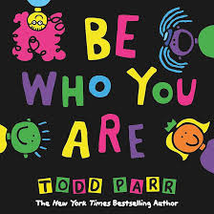  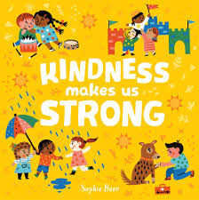  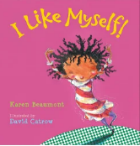  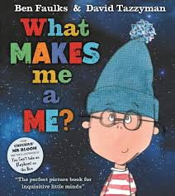  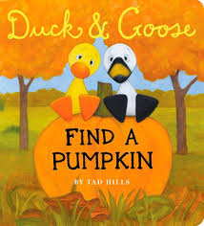  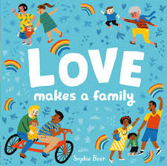  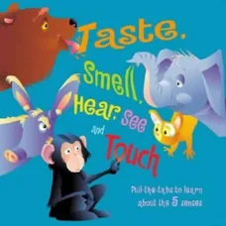  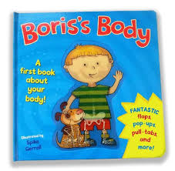 |  | Key Nursery Rhymes  1. Head, shoulders, knees and toes  2. 1 finger, 1 thumb.  3. If you’re happy & you know it.  4. I’ve got a body  5. The finger family  6. 5 little ducks  7.I love you, you love me
Communication and Language  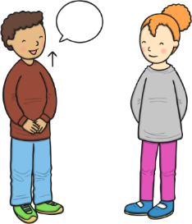  As communicators, the children will be encouraged to pay attention when others are talking and respond when they are spoken to by name. They will be taught basic listening skills, with adults modelling how to listen when someone else is speaking. They will listen to a range of short stories, songs and rhymes all about the themselves and their bodies. They will be supported to join in with any songs, stories and rhymes that are familiar to them. Following instructions is very important so lots of simple instructions with two key words will given for the children to listen to and follow. All children will be encouraged to speak clearly, saying each other’s names correctly and using simple 2 or more word sentences. All adults will ask lots of ‘who’, ‘what’, ‘when’ and ‘where’ questions for the children to try and answer in their clear voices. The nursery will be filled with chatter so the children’s speech and vocabularies develop well. | Personal, Social and Emotional Development  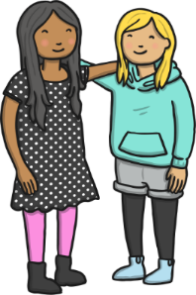  As young citizens, the children will be taught how to use the nursery and it all of its resources appropriately. They will be given lots of freedom and choice to select and use resources which they would like to explore. We will work on settling to an activity for extended periods of time as well as carrying out directed tasks set by the adults, designed to extend key skills and knowledge. We want the children to feel happy and settled and will interact with them lots in the environment so they become confident and feel safe. We will encourage lots of play with others and develop the skills of sharing and taking turns whilst playing with all of the different resources. We will use our Bucket Filling books to talk about expected behaviour in nursery, so that all children treat each other and the environment with care. We want to be bucket fillers not bucket dippers! We will discuss lots of different feelings and emotions through appropriate stories. |  |  | 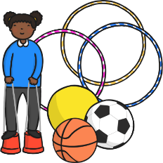  Physical Development  As movers, the children have a weekly dedicated PE slot in the school hall to learn how to use space appropriately and move in different ways. We will also use our great outdoor space to run, jump, hop, skip, climb, throw, catch, roll and crawl.  ~  We will work hard with parents and the children to ensure that all children can use the toilet independently. The children will begin to understand good hygiene and will be able tell an adult when they are tired or hungry. They will learn how to wash and dry their hands independently if they can’t do this already.  ~  Within the provision, there will be a Funky Fingers area with an activity designed to develop the children’s hand control/movements. Our focus this term will be on showing a preference for a dominant hand.
Literacy  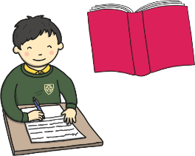  As readers, we will work on pre-reading skills. This includes listening to rhymes and sounds in the environment and using instruments, following ideas given on the Letters and Sounds Scheme (Phase 1). We will read lots of key texts related to the ‘Magnificent Me’ topic and use these to guide the children’s play. Age appropriate books will be used to help the children begin to understand basic letters and print e.g. we read left to right and from top to bottom, how pages are turned, book parts such as front and back cover, etc. We want the children to be able to notice rhyme and be able to clap syllables this half term so we will share weekly rhymes and undertake lots of singing. The children will hear lots of different short stories, songs and rhymes and will be encouraged to join in with any known ones.  ~  As writers, we will develop the children’s gross motor skills by making large marks e.g. using playground chalk, painting with water. We will use Phase 1 ‘Toy Talk’ to develop the children’s understanding of the sounds in words. A big focus will be on supporting the children to use any print knowledge they have to start writing e.g. m for mummy. This half term, we’d like all children to be able to write at least the first letter of their name. |  | Mathematics  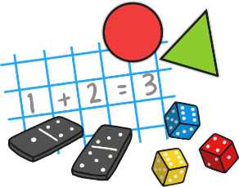  As mathematicians, the children will learn how to confidently recite numbers to 5 and beyond. They will know how to make 2 in different ways, gaining a real grasp of basic number skills.  ~  Within the provision, the children will have lots of opportunities to compare objects – either by size, length, weight or capacity. To develop awareness of time, we will start to use vocabulary to describe the time of the day that things happen e.g. morning, dinner time, afternoon, evening, helping the children differentiate between different parts of the day. The children will also have lots of opportunities to explore and use shapes for building, thinking about which shapes are best for which purpose and why e.g. shapes with flat sides are best for stacking.  ~  We will encourage the children to spot a range of different patterns in the environment and ask them to talk about them e.g. stripes on a scarf, lines on flower petals, etc.
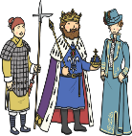  Understanding the World  As historians, the children will be learning all about themselves as individuals, and their friends in the classroom. We will begin to make sense of our own life stories and family history through pictures, stories, conversations and different group activties within our learning environment.  As geographers, the children will learn that there are many different types of family. They will investigate where their family lives and compare this to other families around the world, learning how life varies and how families are similar or different. They will use simple maps and aerial photographs to find where their houses are.  As scientists, the children will learn more about the season of Autumn and Harvest time, making observations about what happens outside at this time of year.    As theologians, the children develop positive attitudes about the differences between people. As a Church School, they will learn our nursery prayers which are recited on entry and at home time. Throughout the term we will seize opportunities to talk about life events.  The children will be given many opportunities to listen and learn new music including a variety of songs relating to the different festivals and celebrations. |  |  | 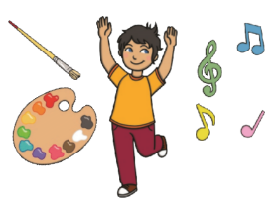  Expressive Arts and Design  As artists, the children will be focusing on colour, paint and portraits this term. The children will explore the artis Picasso and investagte and remake and design their own picasso portrait!  As musicians, the children will begin to learn new nursery rhymes and listen to a rhyme, rhyme and a beat!  The children will also be provided with a variety of music and songs to listen, learn and dance to from an array of different cultures and religions. We will be partaking in the Harvest festival, where we will learn a new topical song!  We will access Charanga’s Song Collection to choose a range of well known, favourite and number songs to support our curriculum and their Listening Activities, which is a collection of stories and listening examples designed especially for younger children. We will also select some of Charanga’s Musical Activities to develop the children’s musical and general skills. These include listening activities, musical games, singing and playing instruments.    As creators, the children will continue to develop their imaginations, role playing our home corner and through other opportunities such as dressing up, using small world characters and accessing a range of props and open-ended resources.

