Langley Mill Church of England Infant School and Nursery – Dazzling Dormice Reception Medium Term Plan – Autumn 1 2025-26
Marvellous Me!  This topic was chosen as it is important for the children to have a really good sense of who they are as an individual and what makes them, them! We will also be investigating who is in their family and what makes their family special to them.  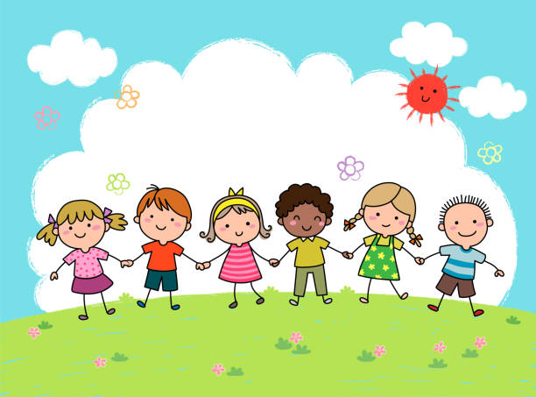  It is important for the children to know why they are special and what makes them unique. They need to know how people are different and similar, starting with those familiar to them then extending to other families in a wider context. The children also need lots of freedom and choice to practise a range of skills and develop knowledge across many areas. | Immersion Events  - Talent Show!  Parent Partnership Events  - Parent consultations – 14, 15, 16.10.25  - Harvest Event in the Early Years – W/C 20.10.25  Reading / Book Events  - Roald Dahl Day - 13.9.25  - National Poetry Day - 2.10.25  - National Libraries Week – W/C 6.10.25  Additional Events  - International Day of Democracy – 15.9.25  - Recycling Week W/C 22.9.25  - Autumn Equinox – 22.9.25 |  | Prior Learning  - In nursery, the children learned all about themselves and focussed on what makes them special and unique. They thought about how they have grown from being babies to toddlers. They gained an awareness of where they live. They experimented with a range of different materials and started to think about the season of autumn, noting key changes that happen at this time of year.  This term in Reception we will be learning...  - In reception, the children will learn all about themselves and their families and how these vary for individuals. They will learn the importance of belonging and feeling loved and cared for. They will look at family trees, thinking about the passing of time for different generations. They will start to learn where their houses are and the area in which they live. They will investigate the properties of different materials within the provision such as floating and sinking and also learn more about what the weather is like, what happens to trees and what animals do in autumn.
Key Text  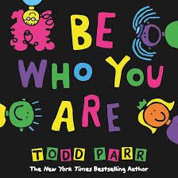  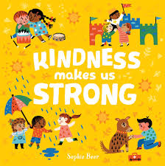  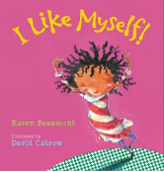  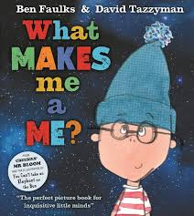  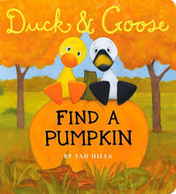  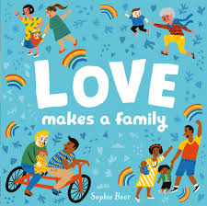  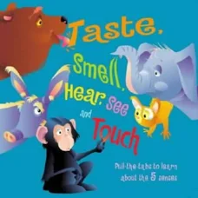  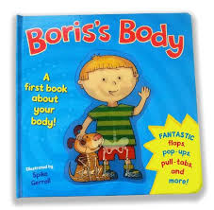 |  | Key Nursery Rhymes  1. Head, shoulders, knees and toes  2. 1 finger, 1 thumb.  3. If you’re happy & you know it.  4. I’ve got a body  5. The finger family  6. 5 little ducks  7.I love you, you love me
Communication and Language  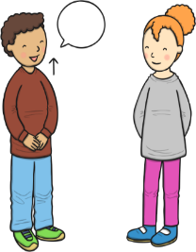  As communicators, the children will share their ideas across all areas of learning. They will talk lots about their family members, and how they are special to them. They will learn and use new vocabulary related to the ‘Fabulous Families’ topic being covered such as mother, father, brother, sister, sibling, grandparent, extended family.  The children will be taught how to show good listening and learn why listening is important.  The children will be encouraged to talk in complete sentences throughout the school day. They will learn key social phrases that relate to the daily routine such as phonics time, collective worship time, choosing time, maths time, dinner time, story time etc.  They will partake in daily story time sessions, with books related to the topic being taught, including non-fiction books. They will also listen carefully to a range of rhymes and songs. | Personal, Social and Emotional Development  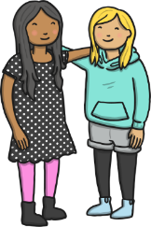  As young citizens, the children will think and talk about themselves, sharing their likes and dislikes and what they are good at. They will find out about their personal history and the history and culture of their families.  They will be encouraged to listen to each other in all that they do, as well as listening carefully to the staff, following their simple instructions.  Throughout the term we will focus on identifying and describing a range of feelings, using lots of stories to prompt discussions.  To ensure a happy and safe environment, the children will learn strategies to help them stay calm and learn why we take turns, wait politely, tidy up, etc. The children will also learn what it means to be a Bucket Filler to ensure that we are a bucket filling school full of positivity and kindness.  Stories will be shared that show characters dealing with challenges, so the children have examples to learn from.  Throughout the first term the children will be supported to manage their own personal hygiene needs such as thorough hand washing and going to the toilet independently. |  | Physical Development    As sportspeople, the children will developing their Athletics skills. They will work on track and field events, including running races and various competitions jumping and throwing.  The children will also be practising fastening buttons, zips, press studs and ties so they can independently dress and undress. They will develop good pencil control when mark making and drawing on a large and small scale. They will also be encouraged to use cutlery and other one-handed equipment properly.  The children will practise all of their physical skills by taking part in Squiggle While You Wiggle lessons and daily Funky Finger activities.
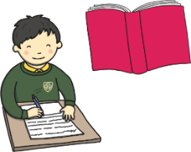  Literacy  As readers, the children will take part in daily 20-30-minutes Little Wandle phonics lessons. Through these lessons the children will learn single sounds and be introduced to their first reading books, which they will be bringing home to share with you. They will also be learning the skill of be able to say sounds in a short word to hear the word and read it. The children will also retell key events in stories, say what has happened so far in stories and start to recall facts from non-fiction.  As writers, the children will practise writing their names. They will also begin to learn how to form some lower case and capital letters correctly. They will start to be able to spell simple words using the sounds they have learned and learn how to spell key sight words such as ‘is, a, the, I, for, of, are, he was, said, all, we’. The children will use their phonics knowledge to write simple captions and labels to match pictures and diagrams. We will spend lots of time practising saying sentences orally. |  | 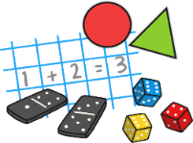  Mathematics  As mathematicians, the children will follow the Mastering Maths Scheme for Number and White Rose Mathematic Scheme for Shape, Space and Measure.  These scheme begin by allowing the children lots of time to explore maths in the classroom and outdoor area, and learning the times of the school day and the class routines. The children will learn where resources belong using positional language such as on, behind, under, beside.  ~  Once we have got to know the children we will move onto number, starting with matching and sorting before comparing amounts. The focus will be on representing, comparing and composition of numbers 1, 2, 3 before moving on to representing numbers to 3 and one more and one less.  ~  During shape, space and measure lessons, the children will compare size, mass and capacity and explore patterns. They will look carefully at circles and triangles before shapes with four sides and time.
  Understanding the World    As historians, the children will think about their own time lines before looking at and discussing photographs of themselves and family members, both recent and from the past. They will use photographs to find out about times gone by such as changes in homes.  As geographers, the children will learn that there are many different types of family. They will investigate where their family lives and compare this to other families around the world, learning how life varies and how families are similar or different. They will use simple maps and aerial photographs to find where their houses are.  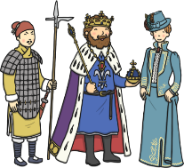  As scientists, the children will learn more about the season of Autumn and Harvest time, making observations about what happens outside at this time of year. |   Expressive Arts and Design  As artists, the children will look at a variety of portraits by famous artists. They will carefully study their own features before drawing simple portraits of themselves and their family members.  As musicians, the children will follow the Charanga music scheme, ‘Me’ unit of work. Through these lessons they will learn how to follow the beat in a song and join in with familiar rhymes. They will use their voice as an instrument and perform a song to a small audience.  As dancers, the children will follow the BBC Let’s Move ‘Autumn’ Unit. The first lesson is all about fireworks and the children will perform a sequence to music and explore different pathways and floor patterns. Lesson 2 focuses on autumn animals and the children will develop everyday actions into dance movements. Finally, they will look at autumn weather, turning and spinning, different pathways and listening and responding to music. |  |   Religious Education  As theologians, the children will follow Derbyshire’s Agreed Syllabus to think about which people are special to them and why. They will also learn about who is special to Christians. They will then think about belonging and how we work together to be part of our small family and school community and the wider local community.  As we are a Church of England School, the children will learn our school prayers which are recited daily at key points of the day (morning, playtime, lunchtime, worship, home time).  All children will also attend daily whole school Collective Worship in the hall focused on our vision “Always our best for God, each other and ourselves” and our Four Langley Mill Foundations: Aspire, Learn, Respect, Serve.  At the end of the term we will all celebrate this special time of year with a Harvest Festival.

