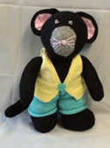 Meet the teacher-Mrs Wilmott. 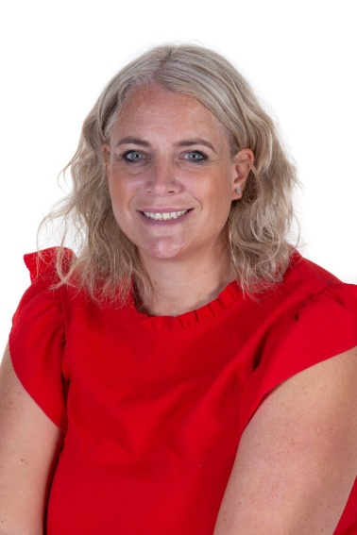

I live locally with my Husband and three children ( although one is officially an adult now!).

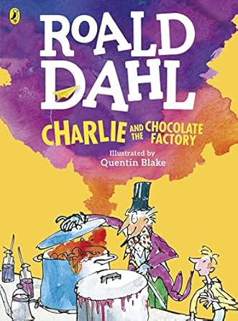

I am enthusiastic about reading and supporting children to foster a love for reading. My favourite children’s book is Charlie and the Chocolate factory.

I love to travel and visit a range of holiday destinations when I can!

Teaching is my dream job, and I am so fortunate to do something I love!