Langley Mill Church of England Infant School and Nursery – Dazzling Dormice Reception Medium Term Plan – Autumn 1 2025-26
Fantastic Festivals!    During this topic the children will learn all about a variety of cultures, religions and beliefs and begin to understand their celebrations. We will celebrate the special celebrations of birthdays and have a birthday party. We will go on to explore all elements of Christmas including the traditional Christmas Story and why we celebrate Christmas. | Immersion Events  - Celebrate a festival  - Santa Experience  Parent Partnership Events  - Christmas Concert  Reading / Book Events  - National Non-Fiction November (Bonfire Night, Remembrance, Winter, Christmas)  Additional Events  - Bonfire Night - 5.11.25  - Remembrance Day - 11.11.25  - Anti-Bullying Week – Theme ‘Power for Good’ – WC 10.11.25 inc. Odd Socks Day 10.11.25  - Children In Need - 14.11.25  - Winter Solstice - 21.12.25 |  | Prior Learning  - Last term, the children learnt all about themselves and their families and how these vary for individuals.  - They learnt the importance of belonging and feeling loved and cared for.  - They will look at family trees, thinking about the passing of time for different generations.  - They began to explore where their houses are and the area in which they live.  - They investigated the season Autumn and the changes that come with it.  This term in Reception we will be learning...  - Learn about a variety of different festivals and the meaning behind them.  - The children will begin to understand a wide variety of cultures and their beliefs, ask questions and explore deeper into why people celebrate in different way.
Key Text  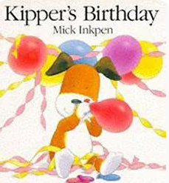  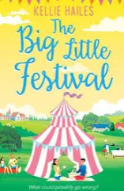  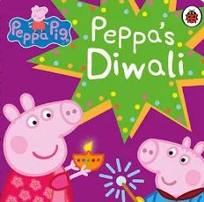  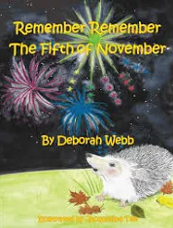  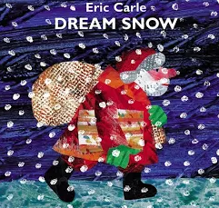  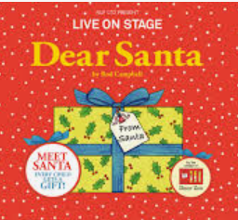  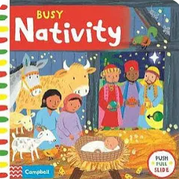 |  | Key Nursery Rhymes  1. Here we go round the mulberry bush  2. Miss Polly  3. Twinkle, Twinkle little star  4. happy birthday to you  5. When santa got stuck up the chimney  6. Twinkle, Twinkle Christmas star  7. Jingle Bells  (plus extra xmas songs for concert).
Communication and Language  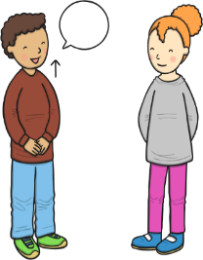  As communicators, the children will share their ideas across all areas of learning. They will talk lots about their family members, and how they are special to them. They will learn and use new vocabulary related to the ‘Fantastic Festivals’ topic.  The children will be taught h  ow to show good listening and learn why listening is important.  The children will be encouraged to talk in complete sentences throughout the school day. They will learn key social phrases that relate to the daily routine such as phonics time, collective worship time, choosing time, maths time, dinner time, story time etc.  They will partake in daily story time sessions, with books related to the topic being taught, including non-fiction books. They will also listen carefully to a range of rhymes and songs. | Personal, Social and Emotional Development  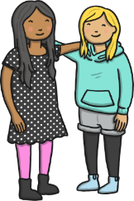  As young citizens, the children will continue to explore and talk about themselves, sharing their likes and dislikes and what they are good at. They will find out about their personal history and the history and culture of their families and celebrations.  They will be encouraged to listen to each other in all that they do, as well as listening carefully to the staff, following their simple instructions.  The children will continue to work on taking turns with their peers during groups activities and free choice time. This will be supported by quick snippet activities through-out the day to support children’s regulation skills.  To ensure a happy and safe environment, the children will learn strategies to help them stay calm and learn why we take turns, wait politely, tidy up, etc. The children will also learn what it means to be a Bucket Filler to ensure that we are a bucket filling school full of positivity and kindness.  Stories will be shared that show characters dealing with challenges, so the children have examples to learn from.  We will continue to express the importance of personal hygiene by continuing to support and encourage the children to manage their own personal hygiene needs such as thorough hand washing and going to the toilet independently.  They will learn about healthy eating and how this helps our bodies and brains stay healthy. |  | Physical Development    As sportspeople, the children will developing their Athletics skills. They will work on track and field events, including running races and various competitions jumping and throwing.  The children will also be practising fastening buttons, zips, press studs and ties so they can independently dress and undress. They will develop good pencil control when mark making and drawing on a large and small scale. They will also be encouraged to use cutlery and other one-handed equipment properly.  The children will practise all of their physical skills by taking part in Squiggle While You Wiggle lessons and daily Funky Finger activities.
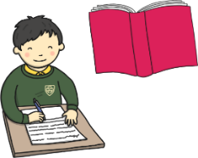  Literacy  As readers, the children will continue to take part in daily 20-30-minute Little Wandle phonics lessons. Through these lessons the children will learn single sounds which link to those in their reading books. They will continue to learning the skill of saying sounds in a short word to hear the word and read it. Children will also practise reading keywords by sight including ‘is, a, the, I, for, of, are, he was, said, all, we’. November is national non-fiction month.  Children will be learning facts about bonfire night, remembrance day and learning information about people who help us through non-fiction books.  As writers, the children will continue to learn how to form some lower case and capital letters correctly. They will start to be able to spell simple words using the sounds they have learnt in phonics and learn how to spell key sight words. The children will use their phonics knowledge to write simple captions and labels to match pictures, and some will begin to write simple 2- and 3-word sentences. |  | 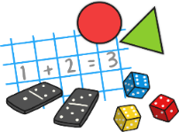  Mathematics  As mathematicians, the children will follow the Mastering Maths Scheme for Number and White Rose Mathematic Scheme for Shape, Space and Measure.  These schemes begin by allowing the children lots of time to explore maths in the classroom and outdoor area, and learning the times of the school day and the class routines. The children will learn where resources belong using positional language such as on, behind, under, beside.  ~  This term, the children will continue to develop their subitising and counting skills and explore the composition of numbers within and beyond 5. They will begin to identify when two sets are equal or unequal and connect two equal groups to doubles. They will begin to connect quantities to numerals.  ~  During shape, space and measure lessons, the children will compare size, mass and capacity and explore patterns. They will look carefully at circles and triangles before shapes with four sides and time.
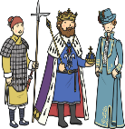  Understanding the World  As historians, the children will be learning all about their world and the world around them through culture, religion and celebrations. We will investigate festivals and celebrations from such as Diwali, Bonfire Night, Hannukah, and Christmas. The children will then be given the opportunity to discuss celebrations that take place in our own homes and compare them to other celebrations and our friends in a positive manner.    As geographers, the children will learn about different religions and cultures from all about the world. Throughout the term we will be talking about many different countries and placing them on a large map that is in our classroom.    As scientists, the children will learn discover new textures and tastes through making and eating lots of different festival foods.    As theologians, the children develop positive attitudes about the differences between people. As a Church School, they will learn our nursery prayers which are recited on entry and at home time. Throughout the term we will seize opportunities to talk about life events.  The children will be given many opportunities to listen and learn new music including a variety of songs relating to the different festivals and celebrations. | 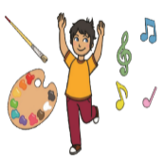  Expressive Arts and Design  As artists, the children will explore lots of different techniques, colours and materials to recreate different festivals objects such as fireworks, sparklers, Mendi patterns and clothing.  As musicians, the children will follow the Charanga music scheme, ‘My stories’ unit of work. Through these lessons they will learn how to follow the beat in a song and join in with rhymes. They will use their voice as an instrument and perform to an audience.  ~  As dancers, the children will follow different dances from Zumba and Danny Go. We will also be learning a range of cultural dances that fit with our topic of festivals. |  |   Religious Education  As theologians, the children will follow Derbyshire’s Agreed Syllabus to think about which people are special to them and why. They will also learn about who is special to Christians. They will then think about belonging and how we work together to be part of our small family and school community and the wider local community.  As we are a Church of England School, the children will learn our school prayers which are recited daily at key points of the day (morning, playtime, lunchtime, worship, home time).  All children will also attend daily whole school Collective Worship in the hall focused on our vision “Always our best for God, each other and ourselves” and our Four Langley Mill Foundations: Aspire, Learn, Respect, Serve.  At the end of the term we will all celebrate this special time of year with a Harvest Festival.

