Langley Mill Church of England Infant School and Nursery – Super Satin Mice (Year One) Medium Term Plan – Autumn 2 2025-2026
Immersion Event  - Baking bread  - The Great Fire of London event  - St Andrews’ Church celebrating the baptism of our class doll. | Parent Partnership Events  - Christmas Concert – December 2025 |  | Reading / Book Events  - National Non-Fiction November  - (Bonfire Night, Remembrance, Winter, Christmas) |  | Additional Events  - Bonfire Night - 5.11.25  - Remembrance Day - 11.11.25  - NSMW –  - AB Week -  - Winter Solstice -
Key Texts  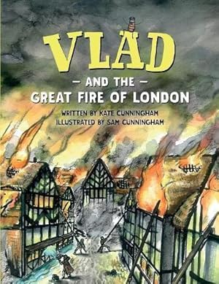  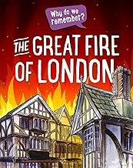 |  | The Great Fire of London  Oh no! Help! Fire, Fire!  There was a huge fire in London!  How did it start? Take a trip back into history to find out about The Great Fire of London and the many positive changes after the fire occurred.   |  | 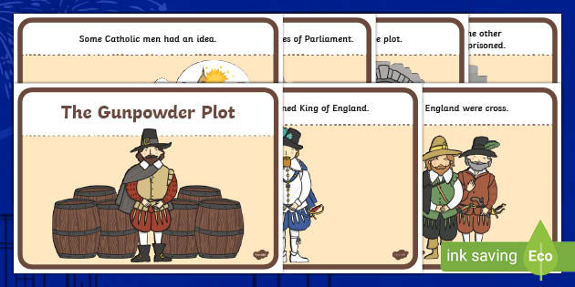  Supporting Texts  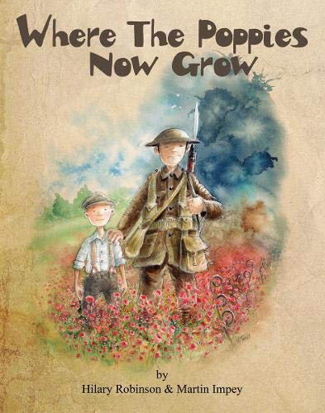  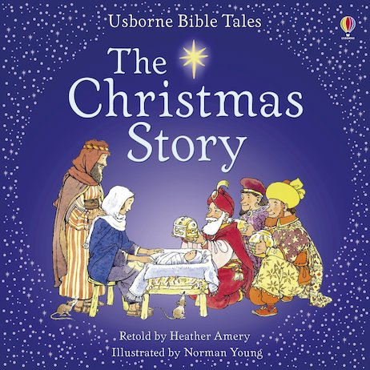
Langley Mill Church of England Infant School and Nursery – Super Satin Mice and Wonderful Wood Mice (Year One) Medium Term Plan – Autumn 3 2023-24
CORE SUBJECTS
  As communicators, the children will share their ideas in all subjects. They will regularly speak to their talk partners, building on the ideas of others to help them plan their own work. Speaking and listening activities will be carried out throughout all lessons to help the children clarify their thinking as well as organise their ideas for writing. They will perform in our Christmas Nativity.  ~  As readers, the children will continue developing their word reading, fluency and comprehension skills. The children will follow the Phonics programme ‘Little Wandle’ and have a daily lesson. As in the previous half term, they will receive a daily Little Wadle lesson which will focus on the phase 5 phonees. The children will hear, share and discuss a range of texts to help develop their reading skills and to learn more about schools. These include non-fiction books about recepies.  ~  As writers, the children will read the story ‘Vlad and the Great Fire of London,’ The children will write a recipe on making bread and they will make bread following their recipe.  Later in the term the children will read the Christmas Story and have a chance to retell this in their own words. |   As mathematicians, will read, write and interpret mathematical statements involving addition (+), subtraction (-) and equals (=) signs. They will add and subtract one-digit numbers to 10, including zero. They will solve one step problems that involve addition and subtraction, using concrete objects and pictorial representations and missing number problems. The children will look at patterns with numbers, shapes and colours. The will practise counting to one hundred, forwards and backwards, beginning with 0 or 1, or from any given number.  The children will also send some time focusing on geometry looking at 2D and 3D shapes, discussing their properties and making patterns.
  As scientists, the children will build on their knowledge of materials from last term. They will use the knowledge they have gained to carry out a variety of investigations linked to properties of materials. They will use the simple properties of materials to help them investigate which materials they would choose is creating a new school raincoat.  ~  Building on learning in Reception and the first half term of Year 1, the children will further observe changes from Autumn to Winter, especially looking at and describing the weather associated with Winter. We will talk about the importance of the Winter Solstice, and what happened to day length before and after this event. They will look for signs of autumn in our school grounds, seeing what is happening to the trees, plants and animals. | 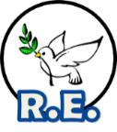  As theologians, the children think about Christians’ views of God. We will think about God as the creator of the earther through the creation story. We will also think about God as part of the Holy Trinity and understand what the Holy Trinity means for Christians.  We are visiting our local church to celebrate a baptism for our class doll.  ~  Near the end of the half term we will look at the importance of the Christmas story to Christians. We will talk about what happened during the first Christmas. We will also think about what people do now to celebrate Christmas.  ~  The children will continue to say our daily school prayers which are recited at key points of the day (morning, playtime, lunchtime, worship, home time). All children will also attend whole school daily Collective Worship in the hall focused on our Four Langley Mill Foundations Aspire, Learn, Respect, Serve.

FOUNDATION SUBJECTS
  As artists, the children will work collaboratively to design a large school collage of London houses . The children will work with a variety of different materials and use these to help replicate the different patterns and textures .As they work together, they will have chance to evaluate their work and spend time changing and improving what they are creating.  ~  As designers, the children will read and follow Christmas instructions to make different Christmas foods and decorations. |   As historians, the children will learn all about the history of London houses and the fire brigade. We will talk about the changes since the Fire of London. Allowing children to put a context on their own learning today.  As Geographical explorers, the children will be able to locate the capital cites of the United Kingdom and the countries that form the United Kingsdom.  ~  We will take a look at the history of both bonfire night and Remembrance Day. Talking about the importance of both of these events to our country, and talk about why we still talk about these events today. |   As young citizens the children will continue to follow the Derbyshire’s PHSE Matters Scheme. This half term they will work through the ‘Bullying Matters’ unit. They will talk about feeling and emotions involved with bullying as well as the correct way to handle situations when other children are being unkind. They will talk about these and link it to the bucket filling learning they already know about
 |   As technologists, the children will learn the Teach Computing 1.2 Digital painting scheme of computing.  Alongside Fire of London art paintings in A&D, choose appropriate tools in a program to create art. The children will  make comparisons between working digitally and non-digitally.  ~  Through all computing lessons the children will be taught how to use computers safely, within the context of a school setting. They will explore why we have rules in school and how those rules help us, and then apply this understanding to rules needed for using computer technology safely. |   As musicians, the children will follow the ‘Rhythm in the way we walk and banana rap’ unit of the Charanga scheme. This is a six-week unit of work. All the learning is focused around two songs: Rhythm In The Way We Walk (Reggae style) and Banana Rap (Hip Hop style). They will Listen & Appraise other styles of music and continue to embed the interrelated dimensions of music through games and singing.  ~  The children will also listen to and learn a range of songs and specific tunes for the end of term Christmas performance.
  ~
  As sports people the children will take part in a variety of invasion games. They will think about the different ways in which a ball can be kicked, thrown, passed, hit and bounced. They will also think about where they can move their selves to when playing a team game. Mr Jeffrey will teach on a Friday.
  Throughout all lessons they will be asked to evaluate their own and their peers ‘performances’ and learn how to get apparatus out and out it away safely.
Langley Mill Church of England Infant School & Nursery – Super Satin Mice & Wonderful Wood Mice (Year One) Medium Term Plan – Autumn 1 2022-23
Subject | Week 1 | Week 2 | Week 3 | Week 4 | Week 5 | Week 6 | Week 7
Immersion Event
Parent Partnership Event(s)
Reading / Book Event(s)
Additional Event(s)
English
Speaking and listening
Reading | Guy Fawkes Story | Where the Poppies Now Grow | Victorian Adventure | Victorian Adventure | School Prospectus | School Prospectus | Christmas Story
Writing
Maths
Science
RE
History
Geography
Art & Design
Design & Technology
PSHE / RSE
PE
Computing
Music
Words of the Day
Monday
Tuesday
Wednesday
Thursday
Friday

