Langley Mill Church of England Infant School and Nursery – Curious Cotton Mice Nursery Medium Term Plan – Spring 3 2025-26
Terrific Transport  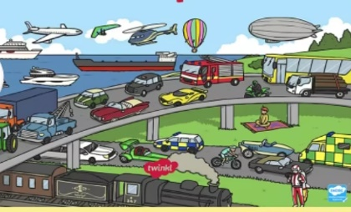  This topic was chosen to develop the children’s understanding of the past, looking at transport now and then, including key figures from the past involved in the history of transport. We will also explore transport that is used around the world. In addition, the children will compare and contrast characters from stories and people from the past. | Immersion Events  Make a junk model mode of transport  Parent Partnership Events  Parent consultations  Reading / Book Events  Winnie the Pooh Day-18.1.26  National Storytelling Week-WC 31.1.26  International Book Giving Day-14.2.26  Additional Events  Safer Internet Day-10.2.26  NSPCC Number Day 6.2.26 |  | Prior Learning  - Before starting nursery the children should have an idea about where they live and who they live with.  - They should have been encouraged to talk in short, clear sentences and be able to understand and follow simple instructions.  - They should attempt to put on / take off coats and shoes with some level of independence.  - They will have experienced drinking from cups and tooth brushing.  - They will have taken part in some family celebrations such as birthdays, anniversaries, weddings and parties.  - They will know the name of different weather types and have experienced what they feel like such as rain, wind, sun, fog and maybe snow  - The children have learned all about themselves and focused on what makes them special and unique.  - They thought about how they have grown from being babies to toddlers.  - They gained an awareness of where they live.  - They experimented with a range of different materials and started to think about the season of autumn, noting key changes that happen at this time of year.
Key Text  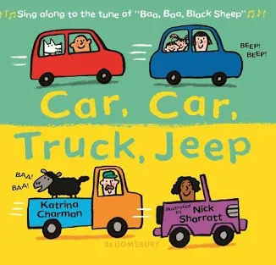  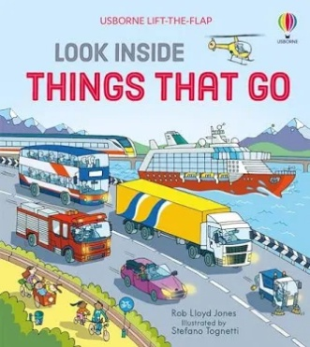  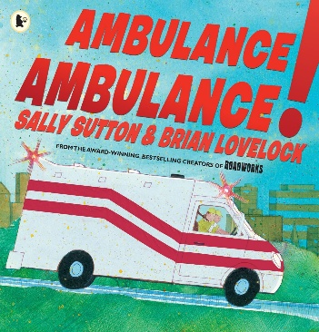  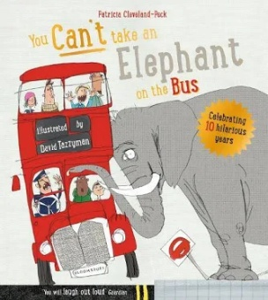  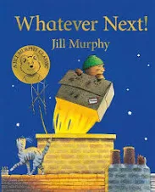  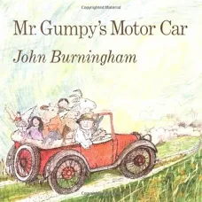 |  | Key Nursery Rhymes  1. Wheels on the bus  2. Driving in my car  3. Riding along on a big red tractor  4. The journey home from Grandpa’s  5. We all go travelling by  6. Down at the Station
Communication and Language  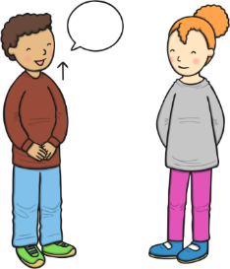  As communicators, the children will be encouraged to listen to the teachers and others for a short period. They will be supported to begin to respond to questions when join in with conversations appropriately and accurately.  The children will partake in an activity known as ‘word of the day’ to enhance and develop the children’s vocabulary. It is important that this term the children are supported to develop and learn new vocabulary and use this to create longer sentences.  The children will be able to follow simple instructions that involve two actions such as “please find your shoes and put them on” | Personal, Social and Emotional Development  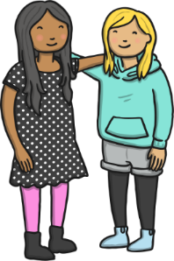  As young citizens, the children will be expected to select and use resources that are available for them to use in the classroom independently or with little help. The children will be given a wide range of different activities to choose from that are changed weekly.  The children will begin to carry out given tasks both independently and in a group. This term there will be opportunities to share, take turns and resolve conflicts using jigsaws and educational games such as red dog, blue dog. To begin with this will be supported by adults in the classroom.  The children will also be supported to name, recognise and describe their feelings. This will be taught in planned lessons and in the moment. The children will feel confident to use our calm corner if and when it is needed to support their emotions and feelings.  We will continue use our Bucket Filling books to talk about expected behaviour in nursery, so that all children treat each other and the environment with care. We want to be bucket fillers not bucket dippers! |  |  |   Physical Development  As movers, the children have a weekly dedicated PE slot, this will take place every Friday. This term our P.E focus is ‘Little Dancers’. This term we are going to focus on both our fine and gross motor skills to enable us to learn lots of new dance routines.  This term there will be a large focus on independence within the nursery. We will be encouraging the children to attend to their own toileting and hygiene needs with little support from the adults.  Within the provision, we will continue to provide a Funky Fingers area with an activity designed to develop the children’s hand control/movements.
Literacy    As readers, we will work on pre-reading skills. This includes listening to rhymes and sounds in the environment and using instruments. We will also be following the scheme Little Wandle, this term we continue to explore the sounds S A T P I N and begin new our new sounds d g o c k e  We will read lots of key texts related to the ‘Terrific Transport’ topic and use these to guide the children’s play. This term there will be an array of both non-fiction and fiction books available for the children to choose from. The children will begin to understand the difference between books that are non-fiction and fiction and choose them appropriately. The children will begin to independently choose stories that interest them and understand how to read left to right and from top to bottom, how pages are turned, book parts such as front and back cover, etc.  This term we will be focusing on rhyme in songs and listening, learning and swapping rhyming words in our songs. We will also begin to hear and listen for initial sounds in our name and familiar words.  As writers, we will develop the children’s gross motor skills by making large marks e.g., using playground chalk, painting with water. We will use Phase 1 ‘Toy Talk’ to develop the children’s understanding of the sounds in words. A big focus will be on supporting the children to use any print knowledge they have to start writing e.g., m for mummy. This term, we will continue to support the children to write at least the first letter of their name. |  | Mathematics  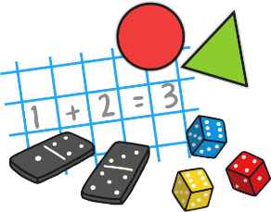  As mathematicians, the children will learn how to confidently recite numbers to 10 and beyond.  This term we will have a big focus on numbers 3-5. The children will participate in a daily, small group activity where they will be supported to use their mathematical skills such as counting on, showing amount on fingers, seeing different amounts in many different ways. This will also be replicated in the continuous provision.  Within the provision, the children will have lots of opportunities to compare different weights, lengths and capacities through activities such as making a measuring wall for the children’s heights, lots of water/ice-based experiments and baking.- 3 triangle 4 squares 2d shapes  The children will continue to develop their awareness of time, each morning the children will change the day, date and month, during this time the children will begin to discuss upcoming events that are happening that week such as birthdays, activities throughout the day or week.
Understanding the World    As historians, the children will be learning all about their world and the world around them through weather and transport. We will investigate different modes of transport and the amazing world that we can travel. We will also investigate how these modes of transport have developed through time. We will begin to look at the different weathers, seasons and terranes in the different countries from around the world.  As geographers, the children will learn about different religions and cultures from all about the world. Throughout the term we will be talking about many different countries and placing them on a large map that is in our classroom.    As scientists, the children will learn all about winter and weather in other countries. We will explore how we get there and why some weathers are different across the world.  As theologians, the children develop positive attitudes about the differences between people. As a Church School, they will learn our nursery prayers which are recited on entry and at home time. Throughout the term we will seize opportunities to talk about life events. |  |  | 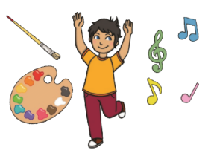  Expressive Arts and Design  As artists, the children will be focusing on printing this term. We will begin to investigate the season and weather around us and use our skills and knowledge of shape and pattern to print and create.  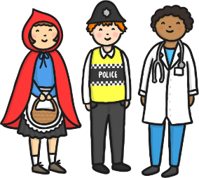    As musicians, the children will continue to learn new nursery rhymes but this term we will be adding our own little twist of changing the word and rhythm.  The children will also be provided with a variety of music and songs to listen, learn and dance to from an array of different cultures and religions.  We will continue access Charanga’s Song Collection to choose a range of well known, favourite and number songs to support our curriculum and their Listening Activities, which is a collection of stories and listening examples designed especially for younger children. We will also select some of Charanga’s Musical Activities to develop the children’s musical and general skills. These include listening activities, musical games, singing and playing instruments.  As creators, the children will continue to develop their imaginations, role playing in our celebrations home corner and through other opportunities such as dressing up, using small world characters and accessing a range of props and open-ended resources.

