Langley Mill Church of England Infant School and Nursery – Dazzling Dormice Reception Medium Term Plan – Spring 3 2025-26
Terrific Transport  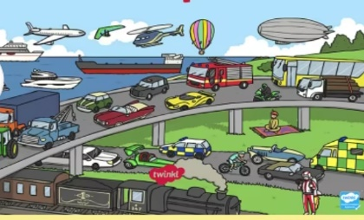  This topic was chosen to develop the children’s understanding of the past, looking at transport now and then, including key figures from the past involved in the history of transport. We will also explore transport that is used around the world. In addition, the children will compare and contrast characters from stories and people from the past. | Immersion Events  Make a junk model mode of transport  Parent Partnership Events  Parent consultations  Reading / Book Events  Winnie the Pooh Day-18.1.26  National Storytelling Week-WC 31.1.26  International Book Giving Day-14.2.26  Additional Events  Safer Internet Day-10.2.26  NSPCC Number Day 6.2.26 |  | Prior Learning  - Last term, the children learnt all about themselves and their families and how these vary for individuals.  - They learnt the importance of belonging and feeling loved and cared for.  - They will look at family trees, thinking about the passing of time for different generations.  - They began to explore where their houses are and the area in which they live.  - They investigated the season Autumn and the changes that come with it.  - Learn about a variety of different festivals and the meaning behind them.  - The children will begin to understand a wide variety of cultures and their beliefs, ask questions and explore deeper into why people celebrate in different way.  This term in Reception we will be learning...  - The children will be looking in more detail at transport from now and those from the past and how they have changed through time. They will also explore key figures who have helped develop transport through history. They will continue to compare and contrast characters from stories and people from the past. As well as exploring transport around the world.  - In addition, we will continue to understand the effects of changing seasons, including animal behaviour during winter.
Key Text  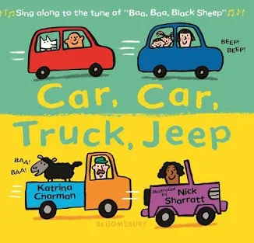  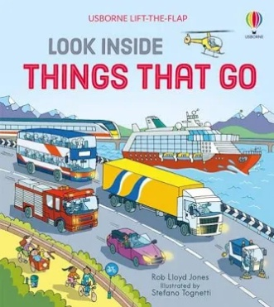  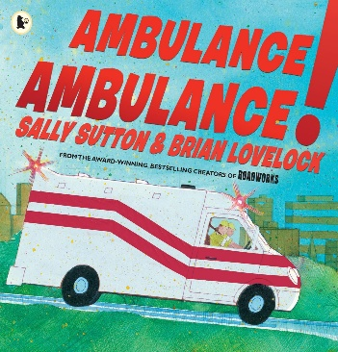  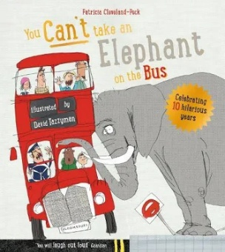  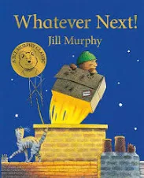  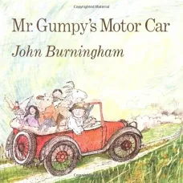 |  | Key Nursery Rhymes  1. Wheels on the bus  2. Driving in my car  3. Riding along on a big red tractor  4. The journey home from Grandpa’s  5. We all go travelling by  6. Down at the Station
Communication and Language  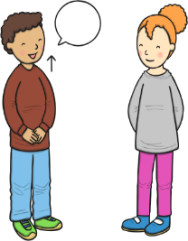  As communicators, the children will share their ideas across all areas of learning. They will learn new vocabulary linked to transport and history e.g. past, present, vehicle. They will ask questions to find out more, using words such as who, why, where?  ~  They will listen and enjoy story time sessions with books related to the topic being taught, including non-fiction books. They will also listen carefully to a range of rhymes and songs.  ~  The children will continue to develop good listening skills, especially during time in our immersive role play areas.  ~  They will be encouraged to describe events in more detail and expand sentences with new vocabulary they have learned throughout our topic. | Personal, Social and Emotional Development  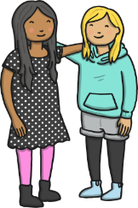  As young citizens, the children will be encouraged to listen and respond to instructions with two or more parts.  ~  Throughout the term we will focus on safety, discussing risks and how to keep our bodies safe, with a focus on road safety.  ~  The children will continue to work on taking turns with their peers during groups activities and free choice time.  ~  They will discuss the challenges that characters in stories face and how they overcome them, what risks they face and how they stay safe.  ~  They will also learn about their own health and wellbeing, in relation to screen time and digital well-being. |  | Physical Development    As sportspeople, they children practise the basic skills of throwing, rolling, catching and dodging. To develop specific game skills, they will follow the DTF PE HRF scheme ‘Dodgeball’ Unit. Through this, lots of activities will be used to help them develop working as part of a team and aiming for a moving target.  ~  As gymnasts, the children will follow the AVSSP DTF Gymnastics scheme and will spend time developing their sequence work and movement memory.  ~  The children will also be practising fastening and zips as they put on their coats, waterproofs, overalls and wellies as we enjoy the outdoor environment all year round.  ~  They will also be encouraged to use cutlery and other one-handed equipment, including scissors and continue to take part in funky finger activities e.g. tweezers, threading etc.  ~  The children will practise all of their physical skills by starting daily sessions of dough disco. This involves moulding playdough in time to music and developing actions such as rolling, flattening and squeezing it to strengthen children’s fine motor muscles. This in turn develops their pencil grip and writing.
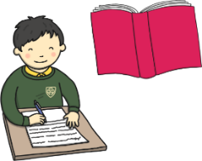  Literacy  As readers, the children will continue to take part in daily 20-30-minute Sounds-Write phonics lessons. Through these lessons the children will learn single sounds which link to those in their reading books before moving onto 2 letters one sound e.g. zz, ff, ll. They will continue to learning the skill of saying sounds in a short word to hear the word and read it. Children will also practise reading keywords by sight including ‘come, some, to, his and she’. We will celebrate Winnie the Pooh Day on 18.1.23 and look at how these characters see themselves as valuable individuals.  ~  As writers, the children will continue to learn how to form some lower case and capital letters correctly. They will continue to develop spelling simple words using the sounds they have learnt in phonics and learn how to spell more key sight words. The children will use their phonics knowledge to write simple captions, and labels to match pictures and some will continue to work on writing simple 3- and 4-word sentences. |  | 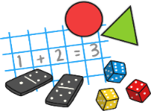  Mathematics  As mathematicians, the children will follow the White Rose Scheme and the Mastering Number.  ~  In number children will continue to develop their knowledge of the numbers 1-5, be introduced to the concept of 0, look at the composition of 4 and 5 and compare numbers from 0-5. They will also begin to find out about numbers 6, 7 and 8 before moving onto combining amounts and making pairs.  ~  During lessons about measure, the children will learn about mass, capacity, length and height. Children will be encouraged to make direct comparisons by holding items and checking with balance scales. They will be prompted to use vocabulary such as, heaviest, heavier, lightest, longest etc. They will also explore capacity through a range of materials and different sized containers, developing their knowledge of full, empty, half full etc, which holds more or less?
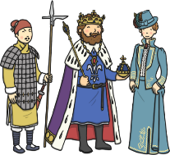  Understanding the World  As historians, the children will learn about transport in the past, make transport timelines and investigate important figures linked to the history of transport.    ~    As geographers, the children will learn about transport in our country and compare it to transport in other countries around the world.  ~  As scientists, the children will learn more about the effect of the changing seasons around them as we explore the winter season. They will explore the world around them and learn about different types of weather, animal behaviours and the different seasons. | 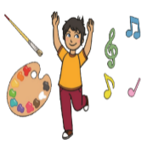  Expressive Arts and Design  As artists, the children will explore a range of printing techniques in order to create pictures of different types of transport.  ~  As musicians, the children will follow the Charanga music scheme, ‘Everyone’ unit of work. Through these lessons they will learn how to follow the beat in a song and join in with rhymes. They will use instruments to copy rhythms and find the beat of the music.  ~  As dancers, the children will follow the BBC Let’s Move ‘Winter Wonderland’ unit. In these lessons’ children will learn about a snowy landscape, developing different movements in time to the music to get dressed up warm for the snow, throw small snowballs and roll large ones. |  |   Religious Education  As theologians, the children will follow Derbyshire’s Agreed Syllabus to think about why the word of God is so important to Christians?  ~  Children will learn that Christians believe God is the giver of life, the creator of the universe and that his name must be respected.  ~  All children will also attend daily whole school Collective Worship in the hall focused on our vision “Always our best for God, each other and ourselves” and our Four Langley Mill Foundations: Aspire, Learn, Respect, Serve.  ~

