Langley Mill Church of England Infant School and Nursery – Dazzling Dormice Reception Medium Term Plan – Spring 4 2025-26
Smashing Spring    This topic was chosen to enable children to learn about the season Spring and the importance that this season has on our ecosystem! This term we are going to delve into the world growing around us. We are going to identify a variety of different animals that are born in Spring and then match the mothers to their babies. The children will also learn what animals produce and the role of the farmer. They will recognise that some environments are different to the ones in which they live. | Parent Partnership Events  Parent Consultations 4.3.26 & 5.6.26  Mother’s Day Celebration – 12.3.26  Easter Concert – 27.3.26  Reading / Book Events  Tell a Fairy Tale Day - 26.2.26  World Book Day - 5.3.26  World Storytelling Day - 20.3.26  International Children’s Book Day - 2.4.26  Additional Events  Shrove Tuesday – 17.2.26  Ash Wednesday - 18.2.26  British Science Week – 7-16th March 26  Spring Equinox - 20.3.26 |  | Prior Learning  - Last term, the children learnt all about themselves and their families and how these vary for individuals.  - They learnt the importance of belonging and feeling loved and cared for.  - They will look at family trees, thinking about the passing of time for different generations.  - They began to explore where their houses are and the area in which they live.  - They investigated the season Autumn and the changes that come with it.  - Learn about a variety of different festivals and the meaning behind them.  - The children will begin to understand a wide variety of cultures and their beliefs, ask questions and explore deeper into why people celebrate in different way.
Key Text  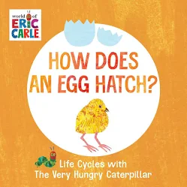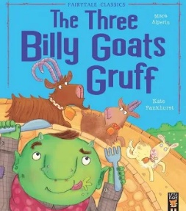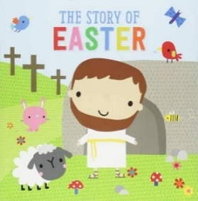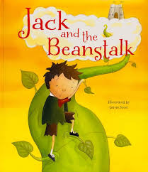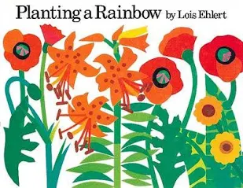  Poems about spring |  | Key Nursery Rhymes  I can sing a rainbow  Baa Baa Black Sheep  Dingle Dangle Scarecrow  Old McDonald  Chick, chick, chick, chicken.
Communication and Language  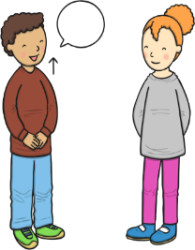  As communicators, the children will have developed their listening skills and will be encouraged to do so for a longer period of time.  The children will continue to develop their listening and communication skills by joining in with conversations appropriately and accurately. It is important that this term the children are support to develop and learn new vocabulary and use this to create longer sentences.  The children will begin to use the new question all to develop and extend their language. They children will be expected to be able to understand and ask why questions in terms of investigations. To support this, there will be a planned ‘question time’ each Tuesday and Thursday.  The children will be able to follow simple instructions accurately that involve two actions such as “please find your shoes and put them on”.~  They will learn songs and rhymes linked to growing, farm animals, seasons and Easter. | Personal, Social and Emotional Development    As young citizens, the children will be expected to select and use resources that are available for them to use in the classroom independently. The children will be supported by the adults to use the outdoor equipment from the shed. There is always a range of different activities for the children to select from whilst in Nursery, they will be given opportunity throughout the day to choose from both inside and outside activities.  The children will continue to carry out given tasks both independently and in a group. This term there will be opportunities to share, take turns and resolve conflicts using a variety of traditional games. The adults within nursery will continue to support the children throughout.  The children will also be supported to name, recognise and describe their feelings. This will be taught in planned lessons and in the moment. The children will feel confident to independently use our calm corner if and when it is needed to support their emotions and feelings.  We will continue use our Bucket Filling books to talk about expected behaviour in nursery, so that all children treat each other and the environment with care. We want to be bucket fillers not bucket dippers! |  | Physical Development  As movers, the children have a weekly dedicated PE slot, this will take place every Friday. This term our P.E focus is ‘Jungle journey’. This story will take the children on a journey that will require them to move in lots of different ways. E.g. slither like a snake. Swing like a monkey.  There will be a focus on ‘match the movement’ games outside. This will include games such as tag, what’s the time Mr wolf, through the hoop.  We will continue to focus on independence within the nursery. We will be encouraging the children to attend to their own toileting and hygiene needs with little support from the adults. This will include going to the toilet and washing their hands independently.  Within the provision we will continue to provide a Funky Fingers area with an activity designed to develop the children’s hand control/movements.  The children will also participate in daily fine motor skills activities, dough disco and squiggle whilst you wiggle
Literacy    As readers, the children will continue to work on their pre-reading skills.  This erm we will be focusing on aspect 5 and 6. During this aspect the children will be delving more into initial sounds, distinguishing between different vocal sounds, including oral blending and segmenting, following ideas given on the Little Wandle  The children will continue to be provided phonics related games in independent learning as well as group taught.  We will read lots of key texts related to the ‘Smashing Spring’ topic and use these to sequence and investigate events of the different stories. The children will be encouraged to use a range of vocabulary from our weekly books and topic-based books provided in our reading area and areas of learning to aid their play during independent learning.  As writers, we will develop the children’s the children’s fine motor skills area within the classroom. The children will continue to develop their cutting, threading, pinch and zipping skills through planned activities. Such as making Mother’s Day and Easter cards.  The children will be supported to use good pencil grip when writing sounds, they hear and see in words. |  | Mathematics  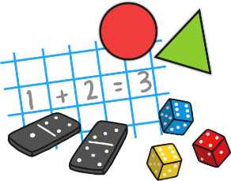  As mathematicians, the children will learn how to confidently recite numbers to 10 and beyond.  This term we will have a big focus on numbers 0-7. The children will participate in a daily, small group activity where they will be supported to use their mathematical skills such as counting on, showing amount on fingers, seeing different amounts in many different ways. This will also be replicated in the continuous provision.  The children will be learning all about 2D and £d shapes during this term. The children will be given the opportunity to investigate a variety of different shapes such as squares, circles, rectangle and squares. We will then be moving on to cubes, cuboids, spheres and pyramids. This will be replicated in the continuous provision.  The children will be given lots of opportunities to compare different weights, lengths and capacities through more outdoor based activities this term. There will be water, weights, jugs, pots, pans, measuring sticks within the continuous provision to support their maths skills.
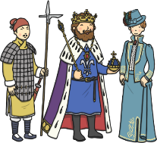  Understanding the World    As geographers, the children will draw information from a simple map as they look at aerial photos of different farms which they will compare to aerial photos of Langley Mill.  We are going to explore different parts of Langley Mill and explore what might grow there and what does not.  ~  As scientists, the children will understand the effect of the changing seasons around them as we move into Spring.  They will discuss the changes that are taking place and look at animal behaviour in Spring. Children will learn about life-cycles and including those of animals and plants. We are going to investigate plants, grow our own and explore the changes that will happen when we look after them appropriately. |   Expressive Arts and Design  As artists, the children will use a variety of materials (including dough) and joining techniques to build models of farms and farm animals.  ~  As musicians, the children will follow our weekly Little Wandle Scheme with a nursery rhyme of the week, matching sounds and different actions. We support this by creating time within the timetable to enhance their musical talents by using different musical instruments.  During Active Time, we are following the ‘Jungle Journey’. This supports both our gross and fine motor skills. We will be moving like different animals working our way through the story of the jungle. |  |   Religious Education  As theologians, the children will follow Derbyshire’s Agreed Syllabus to think about why Christians put a cross in their Easter garden?  ~  Children will learn that Christians believe God is the giver of life, the creator of the universe and that his name must be respected.  ~  All children will also attend daily whole school Collective Worship in the hall focused on our vision “Always our best for God, each other and ourselves” and our Four Langley Mill Foundations: Aspire, Learn, Respect, Serve.

