Langley Mill Church of England Infant School and Nursery – Dazzling Dormice Reception Medium Term Plan – Spring 4 2025-26
Smashing Spring  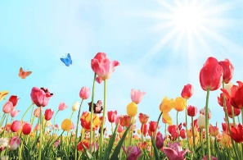  This topic was chosen to enable children to learn about the season Spring and the importance that this season has on our ecosystem! This term we are going to delve into the world growing around us. We are going to identify a variety of different animals that are born in Spring and then match the mothers to their babies. The children will also learn what animals produce and the role of the farmer. They will recognise that some environments are different to the ones in which they live. | Immersion Events  Make a junk model mode of transport  Parent Partnership Events  Parent consultations  Reading / Book Events  Winnie the Pooh Day-18.1.26  National Storytelling Week-WC 31.1.26  International Book Giving Day-14.2.26  Additional Events  Safer Internet Day-10.2.26  NSPCC Number Day 6.2.26 |  | Prior Learning  - Last term, the children learnt all about themselves and their families and how these vary for individuals.  - They learnt the importance of belonging and feeling loved and cared for.  - They will look at family trees, thinking about the passing of time for different generations.  - They began to explore where their houses are and the area in which they live.  - They investigated the season Autumn and the changes that come with it.  - Learn about a variety of different festivals and the meaning behind them.  - The children will begin to understand a wide variety of cultures and their beliefs, ask questions and explore deeper into why people celebrate in different way.  This term in Reception we will be learning...  - The children will be looking in more detail at transport from now and those from the past and how they have changed through time. They will also explore key figures who have helped develop transport through history. They will continue to compare and contrast characters from stories and people from the past. As well as exploring transport around the world.  - In addition, we will continue to understand the effects of changing seasons, including animal behaviour during winter.
Key Text  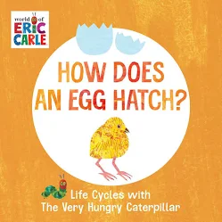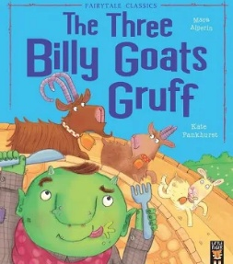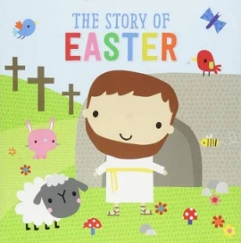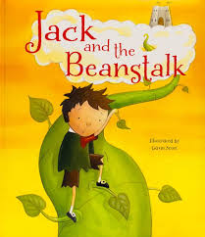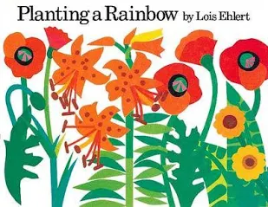  Poems about spring |  | Key Nursery Rhymes  I can sing a rainbow  Baa Baa Black Sheep  Dingle Dangle Scarecrow  Old McDonald  Chick, chick, chick, chicken.
Communication and Language  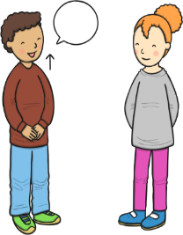  As communicators, the children will share their ideas across all areas of learning. They will learn new vocabulary linked to farmyards e.g. field, windmill, scarecrow. We will also learn about Spring and learn vocabulary as children experience the new season first hand e.g. blossom, bloom, bud. They will ask questions to find out more about farm animals and seasons, using words such as who, why, where?  ~  They will listen and enjoy story time sessions with books related to the topic being taught, including non-fiction books about life-cycles.  ~  The children will describe what they can see in detail as they observe new life e.g. farm animals and chicks during our animal visit day . Children will also explain their own experiences linked to our topic.  ~  They will learn songs and rhymes linked to growing, farm animals, seasons and Easter. | Personal, Social and Emotional Development  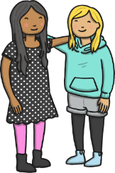  As young citizens, the children will be encouraged to listen and respond to instructions with two or more parts through warm up activities and during play.  ~  The children will continue to work on taking turns with their peers during groups activities and free choice time. We will use the bikes and scooters more this term and children will learn to take turns with the equipment.  ~  Children will discuss the challenges that the goats face in the story ‘The Three Billy Goats Gruff’ and how they overcome the challenges and what risks they take. They will also think about and share other ways that they could have overcome the challenge.  ~  They will think about others feelings as they look at animals’ expressions in the stories. They will discuss how they are feeling and what they might be thinking.  ~  Children will also learn about caring for animals as they handle and observe them. |  | Physical Development    As sportspeople, they children practise the basic skills of throwing, rolling, catching and dodging. To develop specific game skills, they will follow the DTF PE HRF scheme ‘Dodgeball’ Unit. Through this, lots of activities will be used to help them develop working as part of a team and aiming for a moving target.  ~  As gymnasts, the children will follow the AVSSP DTF Gymnastics scheme and will spend time developing their sequence work and movement memory.  ~  The children will also be practising fastening and zips as they put on their coats, waterproofs, overalls and wellies as we enjoy the outdoor environment all year round.  ~  They will also be encouraged to use cutlery and other one-handed equipment, including scissors and continue to take part in funky finger activities e.g. tweezers, threading etc.  ~  The children will practise all of their physical skills by starting daily sessions of dough disco. This involves moulding playdough in time to music and developing actions such as rolling, flattening and squeezing it to strengthen children’s fine motor muscles. This in turn develops their pencil grip and writing.
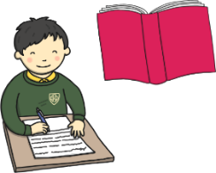  Literacy  As readers, the children will continue to take part in daily 20-30-minute Little Wandle phonics lessons. Through these lessons the children will learn single sounds which link to those in their reading books before moving onto digrpahs e.g. zz, ff, ll, ee, ai, oi, ow, ar and trigraphs e.g. igh ear air. We have now moved on to phase 3 where we are learning all about longer and bigger words using the sounds we have learned. They will continue to learning the skill of saying sounds in a short word to hear the word and read it. Children will also practise reading keywords by sight including ‘come, some, to, his and she’.  ~  As writers, the children will continue to learn how to form some lower case and capital letters correctly. They will continue to develop spelling simple words using the sounds they have learnt in phonics and learn how to spell more key sight words. The children will continue to use their phonics knowledge to write simple captions, and labels to match pictures and some will continue to work on writing simple 3- and 4-word sentences.  Together, on March 3^{rd,} we will celebrate world book day, alongside lots of other lovely reading events this term. |  | 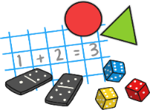  Mathematics  As mathematicians, the children will follow the White Rose Scheme and the Mastering Number.  ~  In number children will continue to develop their knowledge of the numbers 1-5, be introduced to the concept of 0, look at the composition of 4 and 5 and compare numbers from 0-5. They will also begin to find out about numbers 6, 7 and 8 before moving onto combining amounts and making pairs.  ~  During lessons about measure, the children will learn about mass, capacity, length and height. Children will be encouraged to make direct comparisons by holding items and checking with balance scales. They will be prompted to use vocabulary such as, heaviest, heavier, lightest, longest etc. They will also explore capacity through a range of materials and different sized containers, developing their knowledge of full, empty, half full etc, which holds more or less?
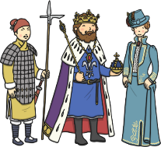  Understanding the World    As geographers, the children will draw information from a simple map as they look at aerial photos of different farms which they will compare to aerial photos of Langley Mill.  We are going to explore different parts of Langley Mill and explore what might grow their and what does not.  ~  As scientists, the children will understand the effect of the changing seasons around them as we move into Spring.  They will discuss the changes that are taking place and look at animal behaviour in Spring. Children will learn about life-cycles and including those of animals and plants. We are going to investigate plants, grow our own and explore the changes that will happen when we look after them appropriately |   Expressive Arts and Design  As artists, the children will use a variety of materials (including dough) and joining techniques to build models of farms and farm animals.  ~  As musicians, the children will follow the Charanga music scheme, ‘Our World’ unit of work. Through these lessons they will continue to work on following a beat and use instruments to copy rhythms and find the beat of the music.  ~  As dancers, the children will follow the BBC Let’s Move Opposites (Spring) unit. This unit explores ‘opposites’ through the context of the arrival of Spring and rabbits enjoying the spring sunshine. The children will spend most of their time working with a partner. There is also an emphasis on the children finding their own ways to develop their movements and incorporate them into a final dance. |  |   Religious Education  As theologians, the children will follow Derbyshire’s Agreed Syllabus to think about why Christians put a cross in their Easter garden?  ~  Children will learn that Christians believe God is the giver of life, the creator of the universe and that his name must be respected.  ~  All children will also attend daily whole school Collective Worship in the hall focused on our vision “Always our best for God, each other and ourselves” and our Four Langley Mill Foundations: Aspire, Learn, Respect, Serve.

