Langley Mill Church of England Infant School and Nursery – Curious Cotton Mice (Nursery) Medium Term Plan – Summer 5 - 2025-26
Mangnigifcent minibeasts  This term our topic is all about MINIBEASTS!  We will explore our wonderful outdoor areas for a variety of different minibeasts, insects and animals. We will then begin to investigate further by looking at the different lifecycles, and habitats!  During this topic we will explore our pond, and go pond dipping , make worm homes and go on a bug hunt!  We will also be fortunate enough to watch the life cycles of a butterfly and ladybirds firsthand!  The butterflies will hopefully be joining us in our first week and the ladybirds in our third week of learning.  Spring is definitely here and we are so excited to explore all the new life and excitement that comes alongside it! | Parent Partnership Events  Parent event w/c 18.05.26  Reading / Book Events  National Share a Story month  Additional Events  ACES Day - 6.5.26  IDAHOBIT - 17.5.26 |  | Prior Learning  - Before starting nursery the children should have an idea about where they live and who they live with.  - They should have been encouraged to talk in short, clear sentences and be able to understand and follow simple instructions.  Autumn Prior learning  - They should attempt to put on / take off coats and shoes with some level of independence.  - They will have experienced drinking from cups.  - They will have taken part in some family celebrations such as birthdays, anniversaries, weddings and parties.  - They will know the name of different weather types and have experienced what they feel like such as rain, wind, sun, fog and maybe snow.  Spring Prior Learning  - The children will be able to name and talk in detail about the different seasons.  - The children will have taken part investigating the life cycles and growing different types of vegetables and plants.  - They will have experienced many different experiments that include ice, water and temperature change.  - The children will be able to name and talk about some of the different animal groups and their key features.
Key Text  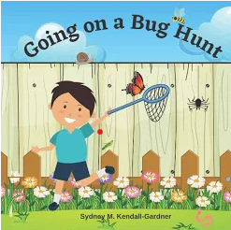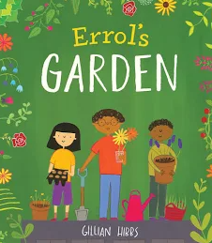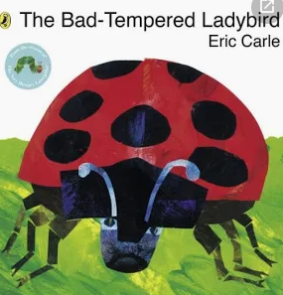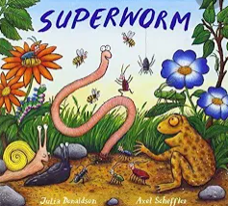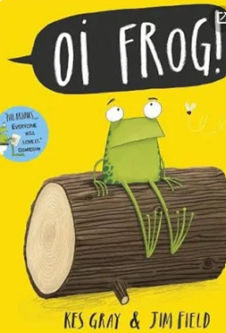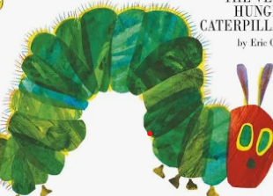 |  | Key Nursery Rhymes  - Incy Wincy Spider  - If I were a minibeast (Makaton)  - The ants go marching  - 5 Little ducks  - 5 Little speckled frogs  - Wiggly Woo
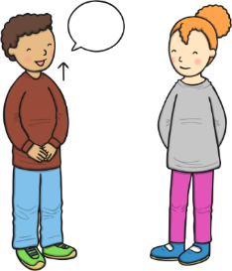  As communicators, the children will have developed their listening skills and will be encouraged to do so for a longer period.  The children will continue to develop their listening and communication skills by joining in with conversations appropriately and accurately. It is important that this term the children are supported to develop and learn new vocabulary and use this to create longer sentences.  The children ill develop a strong understanding communication and language this term. They will partake in communication and language sessions twice a week with will require them to listen and then ask ‘how what why when who’ questions to delve deeper. These sessions will involve looking through dojo portfolios, so please send us lots a picture of what you get up to at home!  The children will be able to follow simple instructions accurately that involve two actions such as “please find your shoes and put them on”. | Personal, Social and Emotional Development  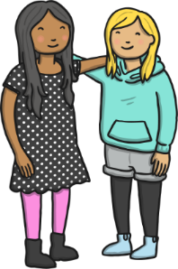  As young citizens, the children will be expected to select and use resources that are available for them to use in the classroom independently. The children will be supported by the adults to use the outdoor equipment from the shed. There is always a range of different activities for the children to select from whilst in Nursery, they will be given opportunity throughout the day to choose from both inside and outside activities.  The children will continue to carry out given tasks both independently and in a group. This term there will be opportunities to share, take turns and resolve conflicts using a variety of traditional games, both teacher and independently led.  The children will also be supported to name, recognise and describe their feelings. This will be taught in planned lessons using emotion coach, stories and mood mats, we will also provide them with support through their independent learning time by ensuring to use emotion coach, provide the children with a calm space, a calm corner and cards of emotion.  The children will feel confident to independently use our calm corner if and when it is needed to support regulate their emotions and feelings.  We will continue use our Bucket Filling books to talk about expected behaviour in nursery, so that all children treat each other and the environment with care. We want to be bucket fillers not bucket dippers! |  |   Physical Development  As movers, the children have a weekly dedicated PE slot. This term our P.E focus is ‘The Little Book of Dance’. The children will use their creative development through dance experiences through a series of flexible sessions. The children will learn to use both their fine and gross motor skills to move it different ways.  There will be a focus on throwing, catching, and bat and games. The children will be given an array of resources such as balls, bats, streamers, frisbees and stilts in the nursery garden to choose from to develop these skills. The children will be given the opportunity to develop their balancing skills through the choice of bikes, scooters and cars.  We will learn to make healthy choices by looking and trying new and healthy foods.  Within the provision we will continue to provide a Funky Fingers area with an activity designed to develop the children’s hand control/movements. During this term the children gain confidence in using one-handed tools and be confident grip when some control when using them. This term we will focus on writing some letters of our name in the correct order.  The children will also participate in daily fine motor skills activities, dough disco and squiggle whilst you wiggle – this is now developing into handwriting sessions during the week too! The children will be provided with their name labels with their name on to find and trace over, leading to independently writing their name!
Literacy    As readers, the children will continue to work on their pre-reading skills.  This term we will be focusing on the sounds  j v w y z qu ch  During this aspect the children will be delving more into initial sounds, distinguishing between different vocal sounds, including oral blending and segmenting, following ideas given on the Little Wandle  The children will continue to be provided phonics related games in independent learning as well as group taught.  The children will be able to talk about stories that we have heard such as the very hungry caterpillar, the grumpy ladybird, were going on a bug hunt and use this to aid their play. The children will be provided a language rich environment with topic-based from books, word of mouth and class research words to support their vocabulary during this term.  As writers, the children will begin to write some letters of their name with good formation with support from an adult. This will be supported through a variety of different writing aids such as pencils, chalk, paper, lined note books, chalk boards, whiteboards, etcher sketchers and more. The children will be supported to use good pencil grip when writing sounds they hear and see in their name and words from around the classroom.  As above the children will be provided with a language rich environment, this provides the children with lots of opportunities to using the phonetical knowledge and practice their writing skills.  As writers, we will develop the children’s the children’s fine motor skills area within the classroom. The children will continue to develop their cutting, threading, pinch and zipping skills through planned activities such as hunt lists, minibeast picture labels, and much more. |  | Mathematics  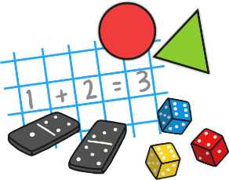  As mathematicians, the children will be following the White Rose Maths Scheme and this term they will learn how to confidently recite numbers to 10 and beyond.  This term we will focusing on subitising up to 3 objects and identifying numbers up to 10. We will begin to investigate words such as greater, less, more, few, equal and use them in the correct context.  We will then explore positional language through the use of maps and BeeBots. The children will be using and learning words such as forwards, backwards, under, over, next to, left and right to ensure their BeeBots go the correct place.  All our learning through-out the term will be replicated in the continuous provision  The children will be given lots of opportunities, within group sessions and independent learning, to compare different weights, lengths and capacities through more outdoor based activities this term. There will be water, weights, jugs, pots, pans, measuring sticks within the continuous provision to support their maths skills.
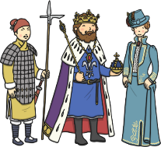  Understanding the World  As geographers, we will explore the pond and the life underneath the water. We will then delve into the life of frogs and where they come from. We will discuss all sorts of amphibians and where they live.  As scientistst. investigate the key features of some insect’s life cycles alongside actually viewing this first hand.    We will investigate the natural environment around us to see what lives, grows and thrives out there. We will investigate how the season has affected our eco-system.  ~  As theologians, the children develop positive attitudes about the differences between people.  As a Christian school the children will be give the opportunity to learn all about different religious stories from the bible and compare them to our own values as small humans. |   Expressive Arts and Design  As artists, the children will use a variety collage materials to recreate pictures we have taken or views we can see, we will then collage a variety of different minibeasts  We will also focus on the artist Goldsworthy and recreate his amazing natural art.  ~  As musicians, the children will be provided with musical instruments in the classroom, they will be expected to tap out rhythms, tap to the beat and dance along to the rhythms they make.  We will continue access Charanga’s Song Collection to choose a range of well known, favourite and number songs to support our curriculum and their Listening Activities, which is a collection of stories and listening examples designed especially for younger children. We will also select some of Charanga’s Musical Activities to develop the children’s musical and general skills. These include listening activities, musical games, singing and playing instruments.  As creators, the children will continue to develop their imaginations, role playing in our Vets and through other opportunities such as dressing up, using small world characters and accessing a range of props and open-ended resources. |  |   Religious Education  As theologians, the children will follow Derbyshire’s Agreed Syllabus within their continuous provision. This we will learn all about Which places are special and why? What is special about our world and why?  ~  Children will learn that Christians believe God is the giver of life, the creator of the universe and that his name must be respected.  ~  All children will also attend daily whole school Collective Worship in the hall focused on our vision “Always our best for God, each other and ourselves” and our Four Langley Mill Foundations: Aspire, Learn, Respect, Serve.

