Langley Mill Church of England Infant School and Nursery – Dazzling Dormice Reception Medium Term Plan –Summer 5 2025-26
Magnificent minibeasts  This term our topic is all about MINIBEASTS!  We will explore our wonderful outdoor areas for a variety of different minibeasts, insects and animals. We will then begin to investigate further by looking at the different lifecycles, and habitats!  During this topic we will explore our pond, and go pond dipping , make worm homes and go on a bug hunt!  We will also be fortunate enough to watch the life cycles of a butterfly and ladybirds firsthand!  The butterflies will hopefully be joining us in our first week and the ladybirds in our third week of learning.  Spring is definitely here and we are so excited to explore all the new life and excitement that comes alongside it! | Parent Partnership Events  Parent event w/c 18.05.26  Reading / Book Events  National Share a Story month  Additional Events  ACES Day - 6.5.26  IDAHOBIT - 17.5.26 |  | Prior Learning  Prior Learning  - In nursery, the children spent lots of time exploring the outdoors including regular forest school sessions in our lovely woodland area.  They looked at changes that occur during different seasons.  - In reception during Autumn term children learnt all about people who help us in our local community. They had visits from community workers where they had the chance to ask questions.  - During spring term children learnt all about different types of transport. They compared transport from now and in the past.  - During reception so far children have developed an awareness of seasons and seasonal change through stories, non-fiction books and first hand experiences including an autumn and winter walk around the school grounds.  This term in Reception we will be learning...  - The children will be learning about minibeasts, planting and growing, life-cycles and shadows. They will learn about requirements for growth as they help to plant and look after fruit and vegetables. We will also think about healthy eating and taste different fruits.  - In addition, children will continue to learn about different seasons as they explore seasonal changes during a walk.
Key Text  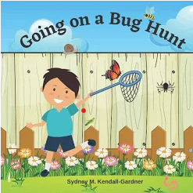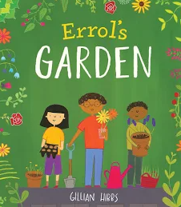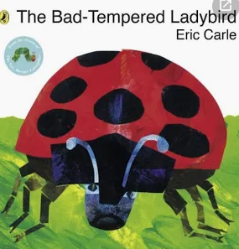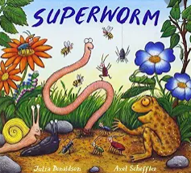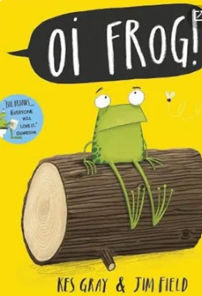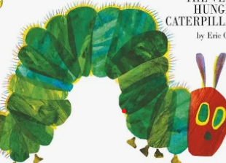 |  | Key Nursery Rhymes  - Incy Wincy Spider  - If I were a minibeast (Makaton)  - The ants go marching  - 5 Little ducks  - 5 Little speckled frogs  Wiggly Woo
Communication and Language  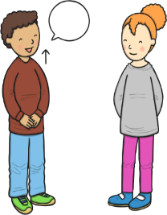  As communicators, the children will share their ideas across all areas of learning. They will learn new vocabulary linked to wildlife, open spaces such as meadows, gardens, parks, different animals, insects, amphibians and minibeasts. We will also continue to explore the season Spring and learn vocabulary as children experience the new season first hand, linking to topical vocabulary such as grow, garden, life. They will ask questions to find out more about our living ecosystem using words such as how, where, what, why, when, who?  ~  They will listen and enjoy story time sessions with books related to the topic being taught, including non-fiction books about life-cycles.  ~  The children will describe what they can see in detail as they observe new life e.g. minibeast and insect life cycles first hand, in the garden and through an array of books. Children will also explain their own experiences linked to our topic using vocab and language they know, and have learned throughout our topic.  ~  They will learn songs and rhymes linked to growing, minibeasts and the changes happening around us. | Personal, Social and Emotional Development  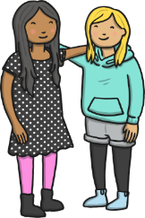  As young citizens, children will revisit class rules after the break and how to look after each other and our equipment/classroom. They will think about how to look after each other and our world e.g. litter pick, caring for minibeasts, and watering plants.  ~  The children will listen to and support each other and follow more complex instructions as they aspire to become happy and caring citizens, supporting the others to do so too.  ~  They will develop problem solving skills and recognise that mistakes are an important part of learning. They will set and achieve own goals through the story ‘The hugging tree’  ~  Children will talk about the different factors that support health and well-being as they think about the importance of exercise linked to the story ‘Going for a walk’  ~  They will learn about healthy eating through the story ‘The Enormous Watermelon’ and taste different fruits. |  | Physical Development    As sportspeople, they children practise the basic skills of throwing, rolling, catching and dodging. To develop specific game skills, they will follow the AVSSP PE scheme, The Football Unit. Through this, lots of activities will be used to help them develop working as part of a team, the gross motor skills and their foot movement.  The children will also be practising fastening and zips as they put on their coats, waterproofs, overalls and wellies as we enjoy the outdoor environment all year round.  ~  They will also be encouraged to use cutlery and other one-handed equipment, including scissors. The children will continue to take part in funky finger activities e.g. tweezers, threading to support their fine motor skills.
  Literacy  As readers, the children will continue to take part in daily 20-30-minute Little Wandle phonics lessons. Through these lessons the children will learn single sounds which link to those in their reading books before moving onto digrpahs e.g. zz, ff, ll, ee, ai, oi, ow, ar and trigraphs e.g. igh ear air. We have now moved on to phase 3 where we are learning all about longer and bigger words using the sounds we have learned. They will continue to learning the skill of saying sounds in a short word to hear the word and read it. Children will also practise reading keywords by sight including ‘come, some, to, his and she’.  ~  As writers, the children will continue to learn how to form some lower case and capital letters correctly. They will continue to develop spelling simple words using the sounds they have learnt in phonics and learn how to spell more key sight words. The children will continue to use their phonics knowledge to write simple captions, and labels to match pictures and some will continue to work on writing simple 3- and 4-word sentences.  Together will celebrate National Story telling month by sharing, editing and making up our own stories. |  | 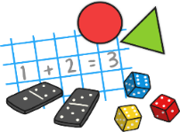  Mathematics  As mathematicians, the children will follow the White Rose Scheme and the Mastering Number.  ~  In number children will continue to develop their knowledge of the numbers 1-5, be introduced to the concept of 0, look at the composition of 4 and 5 and compare numbers from 0-5. They will also begin to find out about numbers 6, 7 and 8 before moving onto combining amounts and making pairs.  ~  During lessons about measure, the children will learn about mass, capacity, length and height. Children will be encouraged to make direct comparisons by holding items and checking with balance scales. They will be prompted to use vocabulary such as, heaviest, heavier, lightest, longest etc. They will also explore capacity through a range of materials and different sized containers, developing their knowledge of full, empty, half full etc, which holds more or less?
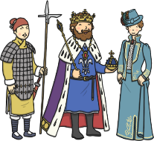  Understanding the World  As geographers, the children will explore the wildlife around us and together discuss why the animals prefer to live in different areas of our gardens, for example, why some animals live in meadows and some animals live in the trees. We will discuss different habitats from not only our own garden, but from around the world too. For example, do frogs just live in our pond?    As scientists, the children will use their prior knowledge about the season Spring the effect of this on our ecosystem, and the animals/minibeasts that grow around them.  Children will learn about life-cycles of a variety of minibeasts around us, we will explore the changes that happen when we look after them appropriately and compare how they are all different from one another. |   Expressive Arts and Design  As artists, the children will use a variety of materials (including dough) and joining techniques to build models of farms and farm animals.  ~  As musicians, the children will follow the Charanga music scheme, ‘Our World’ unit of work. Through these lessons they will continue to work on following a beat and use instruments to copy rhythms and find the beat of the music.  ~  As dancers, the children will explore moving in different ways as they crawl like a beetle, fly like a butterfly and wiggle like a worm. |  |   Religious Education  As theologians, the children will follow Derbyshire’s Agreed Syllabus to think about ‘which places are special and why?’ During this syllabus, we will discuss a variety of different religions and their special places. We will also discuss our special place and what makes it so significant to us.  ~  Children will learn that Christians believe God is the giver of life, the creator of the universe and that his name must be respected.  ~  All children will also attend daily whole school Collective Worship in the hall focused on our vision “Always our best for God, each other and ourselves” and our Four Langley Mill Foundations: Aspire, Learn, Respect, Serve.

