Summer 1 Homework SSM
Please complete 3 tasks this half term from the choices below. You must create a line (by colouring in the boxes you have achieved) that goes through the middle. This can be done in any direction (up/down, side to side or diagonally). You must complete the middle one but can then choose 2 others to complete a line. Please colour the boxes for the tasks you have completed. You can send completed tasks into school or take photos and put them in your child’s portfolio on dojo. If you want to do more than 3 tasks, please feel free to do as many as you want. Thank you and I look forward to seeing what you do at home. Topic: Castles and Crowns.
Research a Castle in the UK and draw/write any facts about the Castle. | Use weighing scales to weigh ingredients for making food! | Would you like to live in a Castle? Draw and write about life if you lived in a Castle. What would you choose to be?
Thinking about our last topic ‘Outstanding Oceans’, draw and label a sea creature that you came across from the Birmingham Sealife Centre. | Read 5 times a week, every week and record in your reading record.  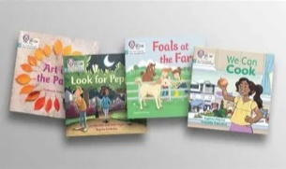 | Design and build a Castle (Can be boxes/Lego etc). How will you protect the King and Queen?
Design a Crown fit for a King/Queen. | Write a list of food fit for a Royal banquet! | Measure using a ruler/tape measure in centimetres (CM) your objects in your house.

