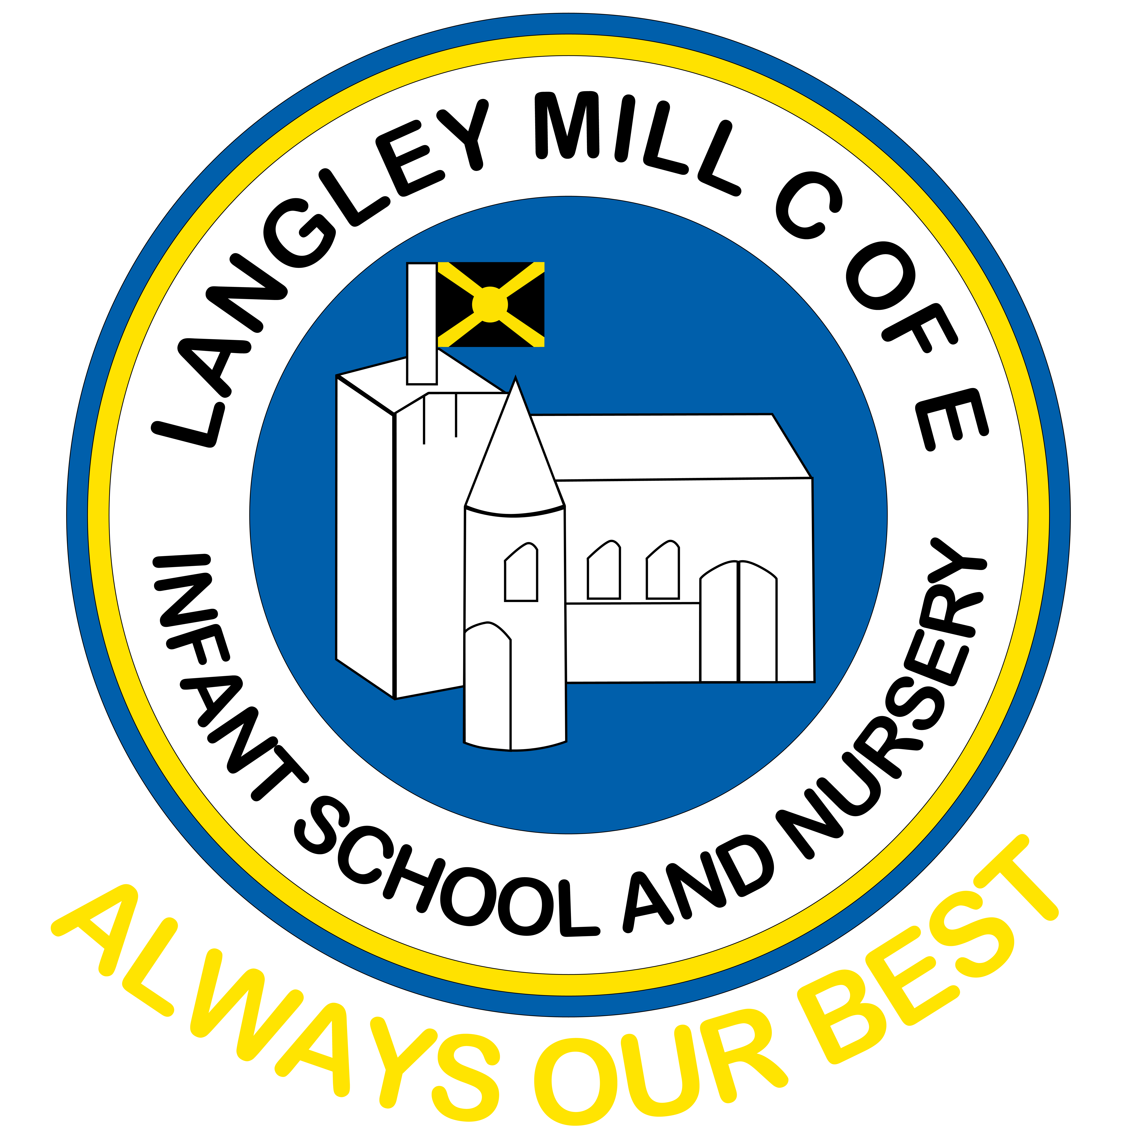Summer reading challenge 2026
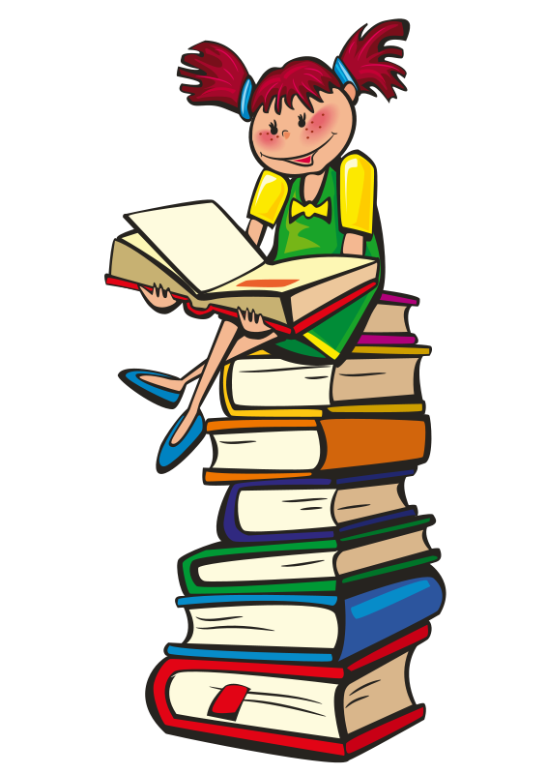
Reading is a priority in our school and we ask that you read at home with your child at least five times a week. We don’t want reading to be limited to term times so, to keep your reading brain working we would like all children to take part in our Summer Reading Challenge over the summer holidays.

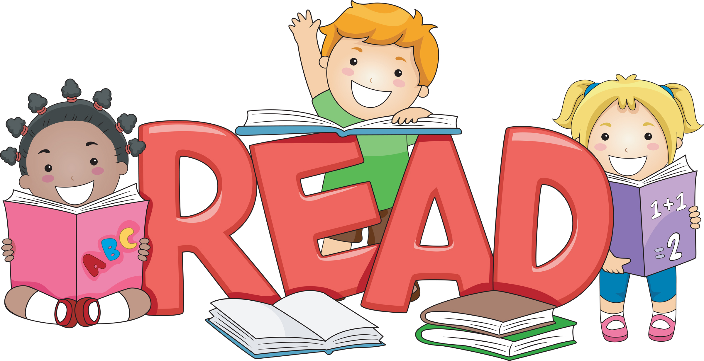Remember, you don’t have to always read books, read other things too; comics, menus, online books, street signs, shopping lists, songs and rhymes etc. It’s all reading!

The children who are coming into the Dazzling Dormice in September have a Reading Bingo Challenge.
Simply shade in the boxes when you have completed the task with your adult.

How many can you complete before the end of the summer holidays?

Bring your completed challenge back to school with you in September to receive your certificate and prize.
Summer Reading challenge 2026

Read a book on the 9th August as it’s National  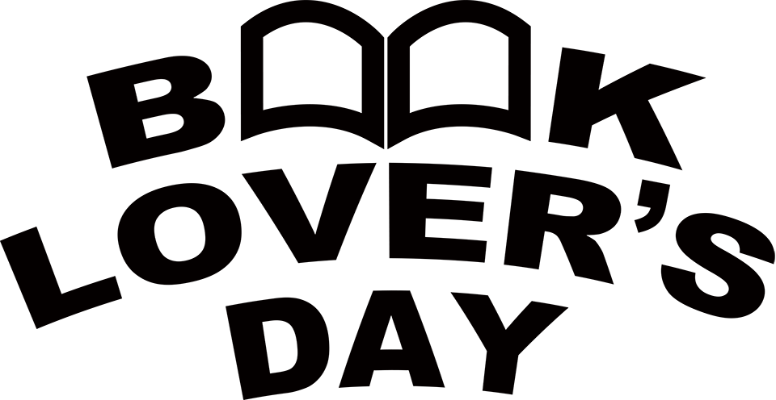 | 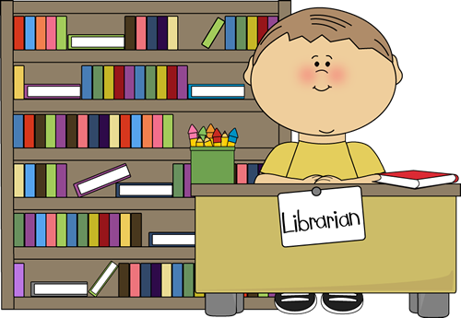  Visit a library | Read to a pet or toy animal  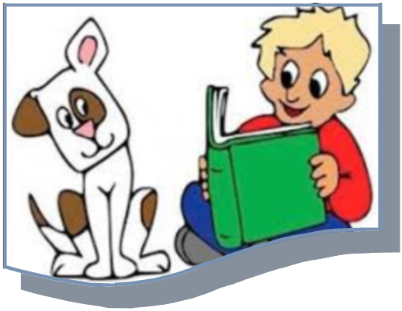
Talk about your favourite story | 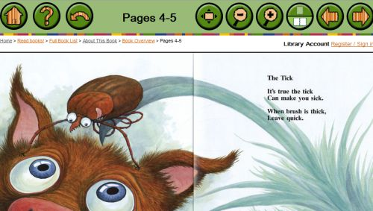  Read an online book | Read outside  
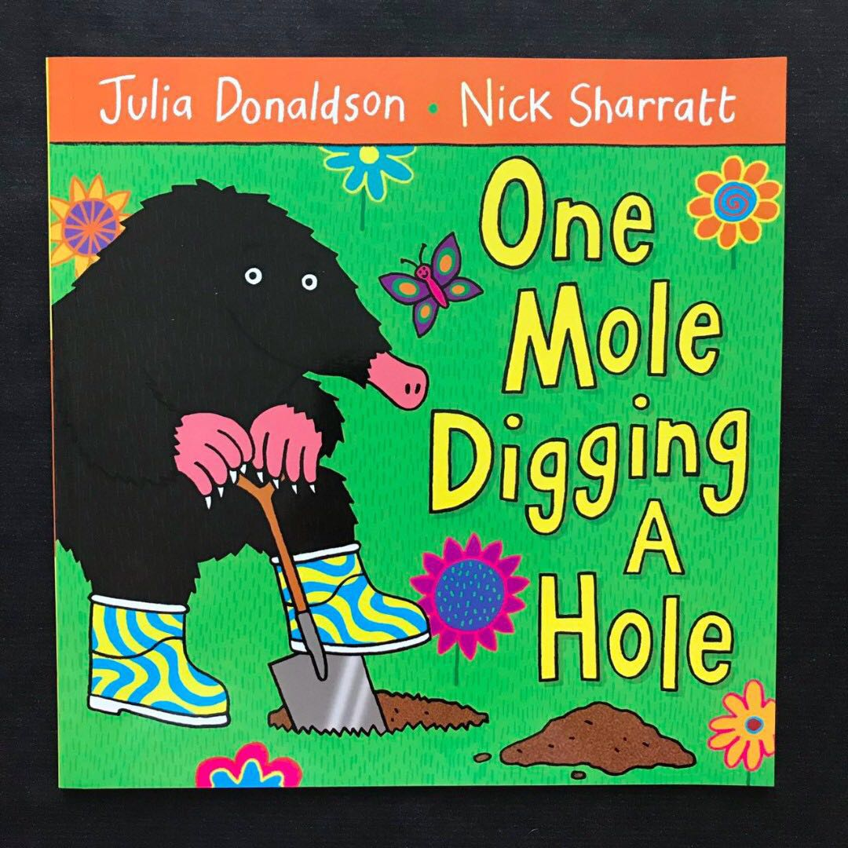  Read a story about an animal you like | Read on holiday or a day trip  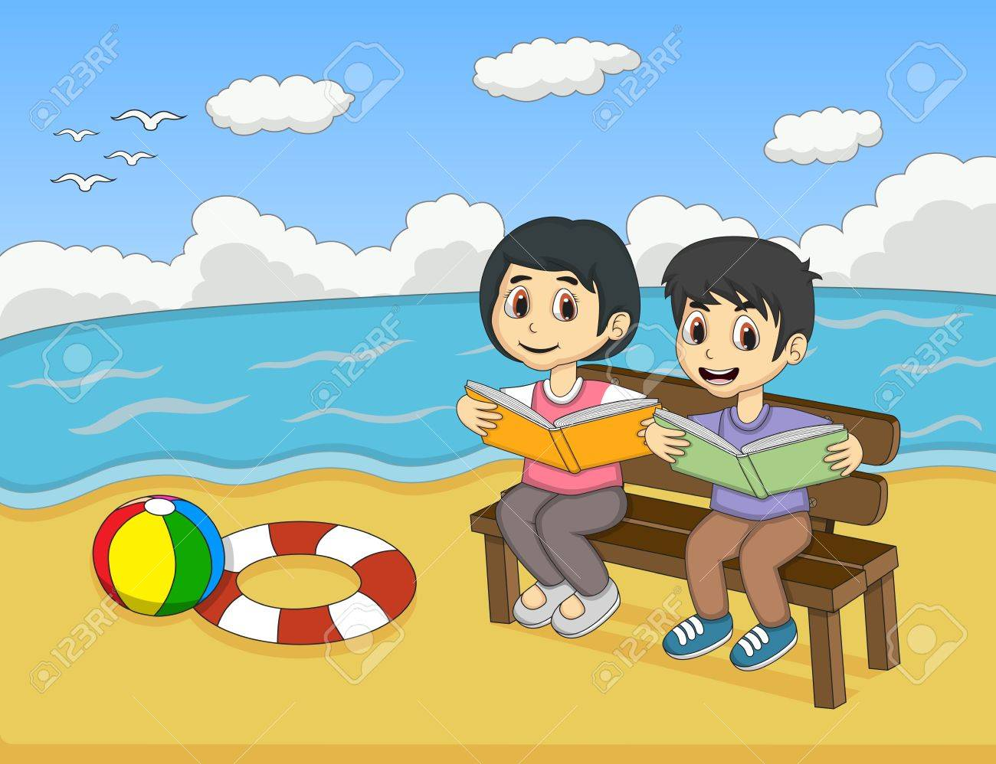 | Ask an adult to tell you about their favourite story
Learn a new nursery rhyme  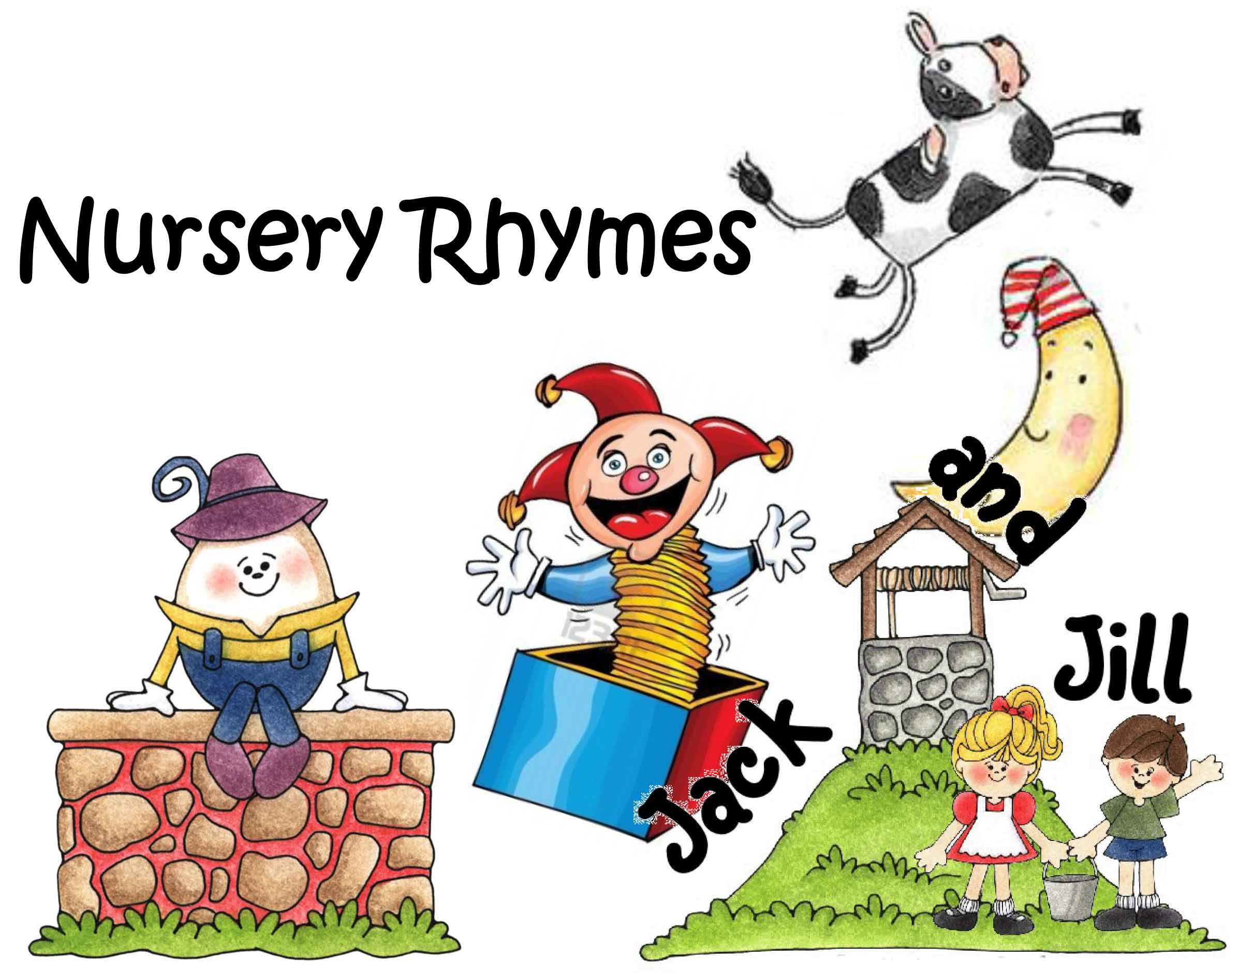 | Read a recipe, why not try and bake it too! Yum! | Make a stick puppet  