


Summer reading challenge 2026
Reading is a priority in our school, and we ask that you read at home with your child at least five times a week. We don’t want reading to be limited to term times so to keep your reading brain working we would like all children to take part in our Summer Reading Challenge over the summer holidays.

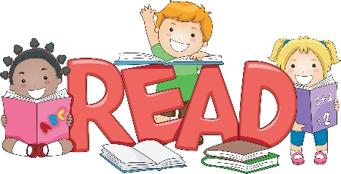
Remember, you don’t have to always read books, read other things too; comics, menus, online books, street signs, shopping lists, songs and rhymes etc. It’s all reading!

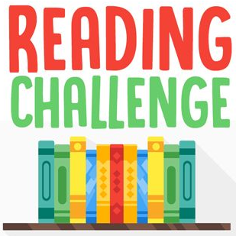
The children who will be Super Satin Mice in September have a Challenge to read to lots of different people in lots of different places.

How many can you complete before the end of the summer holidays?

Tick them off as you complete them and bring your completed challenge back to school with you in September to receive your certificate and prize.

Summer reading challenge 2026

Super Satin Mice

Return to Mrs Wilmott
Name.........................


Read on the 9^{th of} August because it’s National
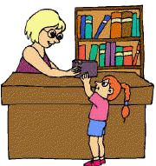
Read a book at the library


Read to an adult

Read under the covers

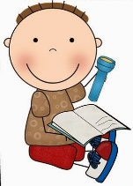
Read to an audience of teddies or dolls

Read with a torch


Read to a younger child

Read under a tree

Read in the car or on a bus

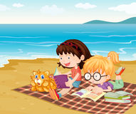
Read to an older child

Read on the beach or in a sandpit


Act out a book to a friend

Read in every room in your house

